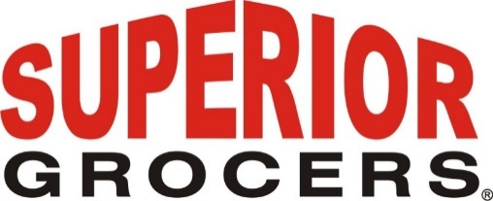

**Superior Grocers Expands Its Reach with the Grand Opening of 72nd Store in Dinuba, CA**

**Santa Fe Springs, CA (February 8, 2024)** – Superior Grocers, a leading grocery retailer, proudly inaugurated its 72nd store in Dinuba, California, on February 7, 2024, at 9:00 AM. This significant expansion marks a milestone achievement for Superior Grocers and underscores its commitment to serving communities across California.

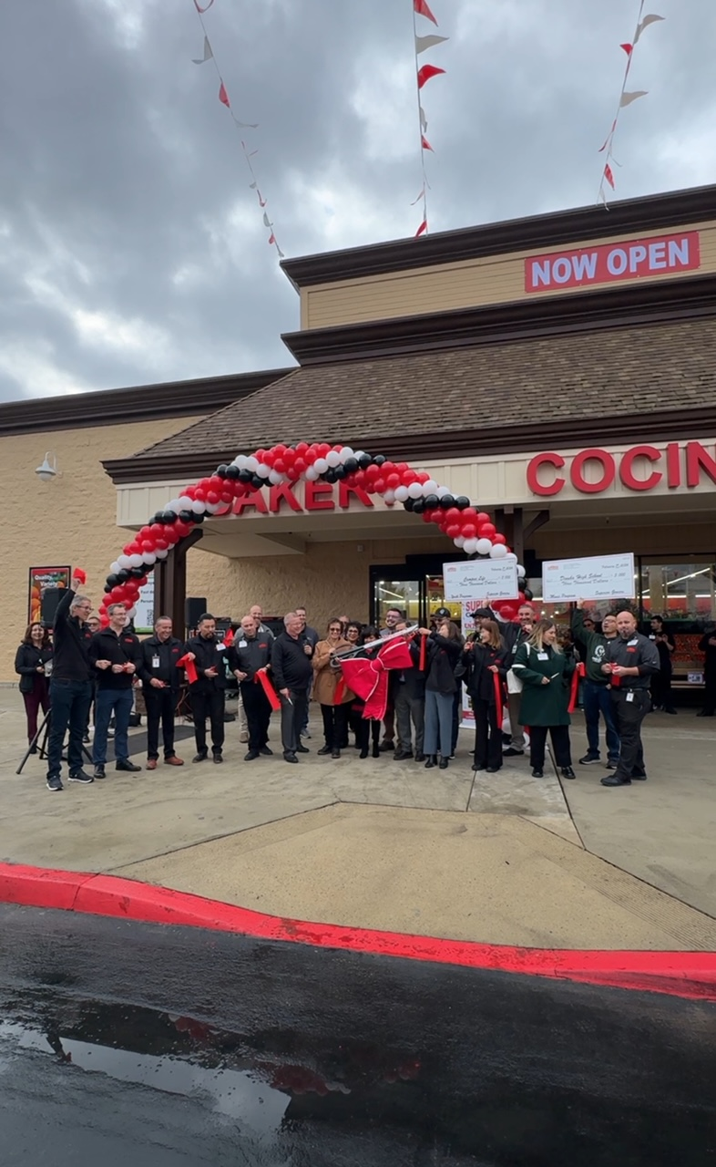

The grand opening ceremony was attended by local elected officials, including:

* Mayor Maribel Reynosa
* Vice Mayor Rachel Nerio-Guerrero
* Councilmember Kuldip Thusu
* Eddie Valero – Supervisor, District Four, County of Tulare

Their presence highlights the strong support and enthusiasm of local leadership for Superior Grocers' entry into the Dinuba market.

Community Engagement:

Superior Grocers demonstrated its dedication to supporting education and community development by presenting a $3,000 check to Dinuba High School during the grand opening event. Additionally, another check was presented to the non-profit organization Campus Life, reinforcing the company's commitment to investing in the future success and well-being of Dinuba's youth.

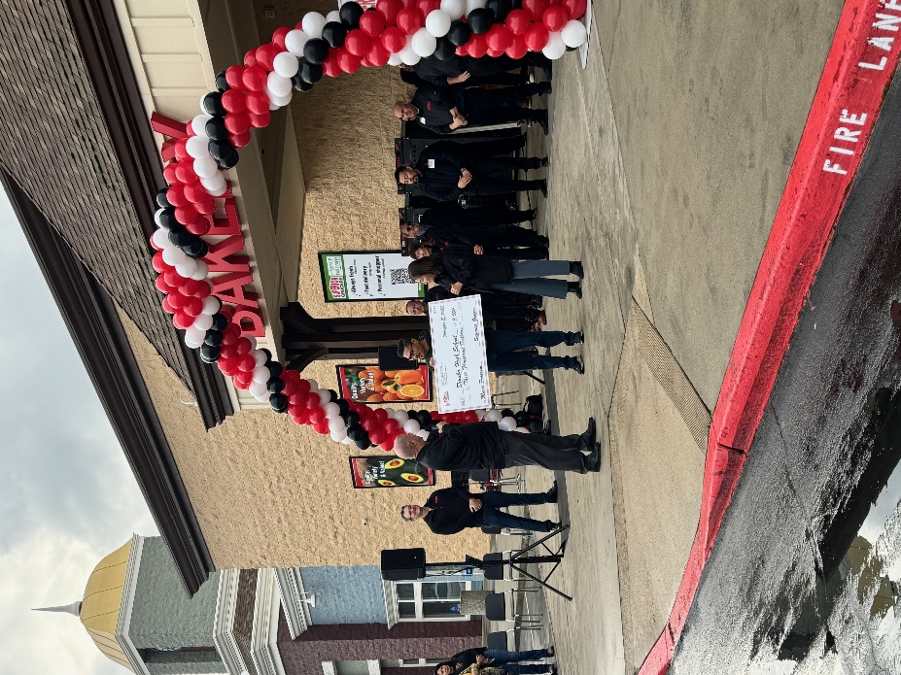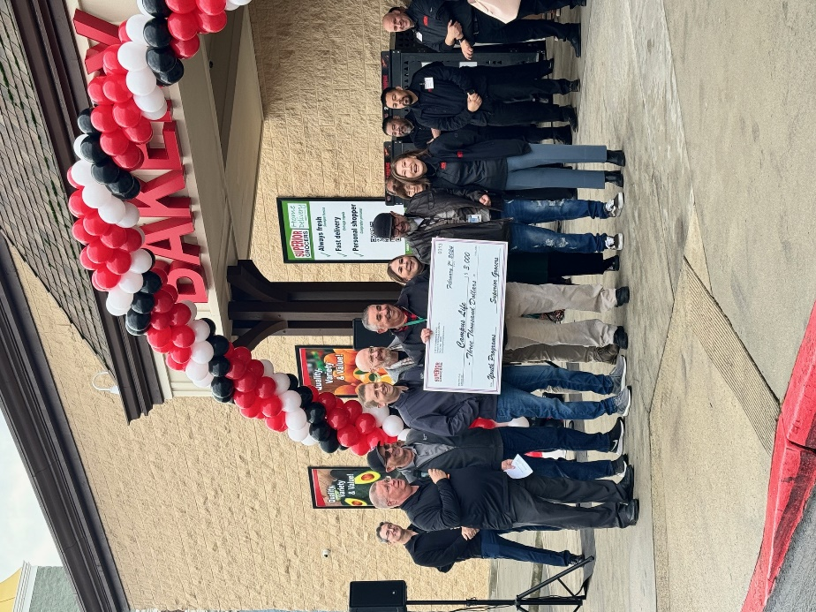

Store Highlights:

The new Superior Grocers store in Dinuba offers a wide range of departments catering to various needs and preferences:

* Fresh Produce Section: A vibrant assortment of locally sourced and fresh produce awaits customers, ensuring quality and freshness.
* Meat and Seafood Department: Offering premium cuts of meat and a diverse selection of seafood to satisfy every culinary preference.
* Bakery: Indulge in freshly baked bread, pastries, and desserts crafted with care by skilled bakers.
* Prepared Foods: Enjoy a variety of freshly prepared meals and dishes, providing convenient options for every occasion.
* Grocery Aisles: Stocked with an extensive range of pantry staples, international products, and specialty items to meet every household's needs.
* Tortilleria: Experience the tradition of handcrafted tortillas, adding a touch of authenticity to every meal.

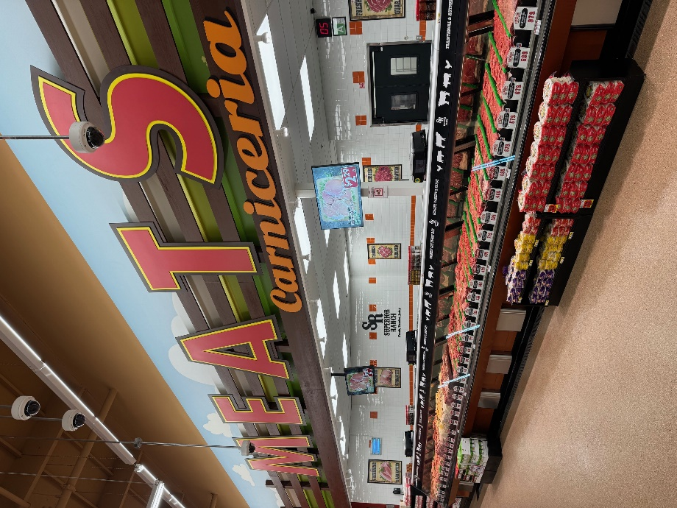 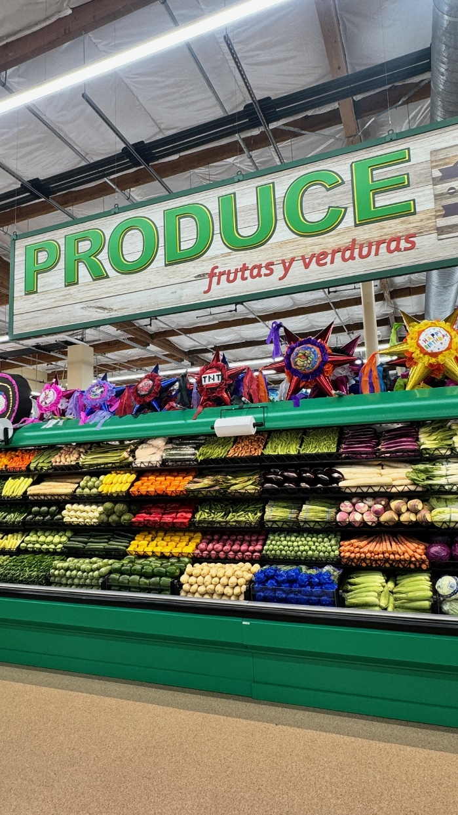

The grand opening drew an enthusiastic crowd, with customers eagerly waiting in line around the building, eager to experience the superior shopping experience offered by Superior Grocers.

"We are excited to open our 72nd store in Dinuba and provide the community with a superior shopping experience," said Richard Wardwell, CEO and President at Superior Grocers. "Our commitment to quality, variety, and exceptional customer service remains unwavering as we embark on this new journey. We are grateful for the warm welcome from Mayor Reynosa, Vice Mayor Nerio-Guerrero, Councilmember Thusu, and all the attendees. We look forward to serving the residents of Dinuba and becoming an integral part of their lives."

Superior Grocers invites residents of Dinuba to visit the new store, explore its diverse offerings, and experience the difference that has made Superior Grocers a trusted name in the grocery industry.

**About Superior Grocers**

Superior Grocers is one of the largest independently owned chain of grocery stores in Southern California. Superior began its operations in 1981 with one store and has experienced steady growth for over 42 years. It now operates 72 stores throughout Southern California and Central Valley. Aside from its wide assortment of grocery, produce, meat, bakery, frozen, deli, international foods & general merchandise products, Superior stores also offer a variety of freshly prepared products in the Bakery, Meat & Seafood, Service Deli and Hot Foods departments.

It prides itself in providing Superior Quality, Superior Variety and Superior Value to the communities that it serves. Superior Grocers is a strong community partner and continually supports programs that help bring a positive impact to its customers, including education, health awareness efforts and many local youth organizations and non-profit groups. For more information about Superior Grocers, please visit [www.superiorgrocers.com](http://www.superiorgrocers.com).

**@SUPERIORGROCERS**

Image result for facebook png Image result for instagram png

**Visit Our Website**

**Superiorgrocers.com**