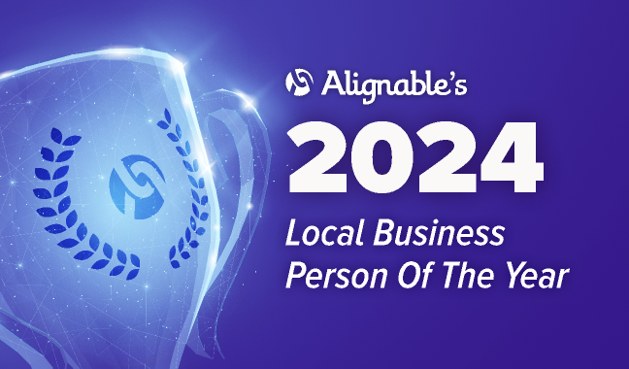

Mike Gross Of Outplay Marketing Honored As
Land O Lakes’ 2024 Local Business Person Of The Year

BOSTON, MA: March 5, 2024 -- Alignable’s 2024 Local Business Person Of The Year Contest reached unparalleled participation levels, logging a whopping 309,000+ votes, 64,000+ recommendations, and an unheard of number of local winners – over 5,100 across the U.S. and Canada.

The largest online networking platform for business owners, Alignable.com invited its 8.7 million+ members to shout-out local business leaders who’ve gone above and beyond guiding peers and supporting entire communities, amid challenging economic conditions.

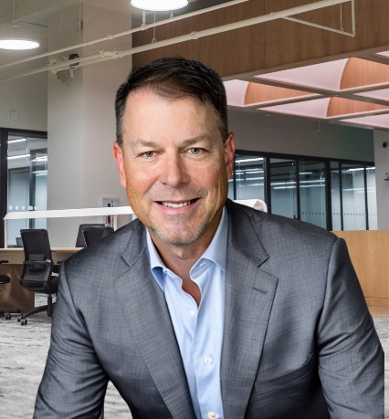
Today, Alignable’s network announces that Mike Gross of Outplay Marketing has been elected as Land O Lakes’ 2024 Business Person Of The Year!

The 2024 contest is the most popular competition Alignable has hosted in over five years, marking a 40% jump in participation over 2023.
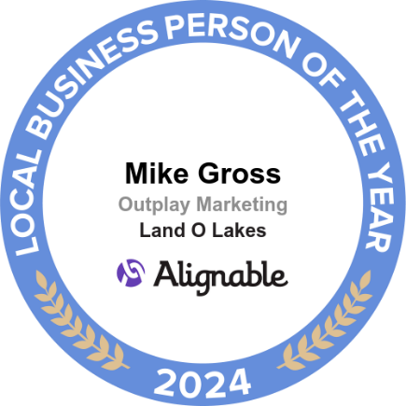
During the 2024 contest, which ran from Jan. 8 to Feb. 23, 2024, 5,171 business owners emerged as winners (including ties), across 4,820 communities. That’s an increase of 1,195 additional Local Business People Of 2024 compared to 2023.

These leaders were commended for helping their peers and communities through a year with many challenges, including rising interest rates and rents, not to mention skyrocketing supply costs.

“In our local business community, we look out for each other and refer businesses down the street or around the corner to help make everyone in town as successful as possible,” said Gross. “And the challenges we’ve all encountered have compelled many of us to offer counsel to peers fighting to keep their businesses afloat. While I’m thrilled to receive this award, it’s really a testament to our entire community.”

Gross received a special badge on his Alignable profile, recognizing this big win. In past years, the awareness generated through similar contests has spurred expanded connections, as well as new business for many winners.

Driving Recognition, Relationships & Referrals
“Our members can't stop raving about how this contest supercharged the relationships within their networks, which have sparked referrals, ignited fresh business opportunities, and fueled an unstoppable wave of mutual support," said Eric Groves, CEO and Co-Founder of Alignable. “Small business owners are the vibrant heartbeat of their communities, and it's high time they got the recognition they deserve. With over 64,000 recommendations pouring in from this year's contest, it's crystal clear: when small business owners unite, they become an unstoppable force."

To arrange interviews withMike Gross and/or an Alignable representative, please contact Chuck Casto at chuck@alignable.com. He also can offer JPEGs and other visuals, as well as local winner testimonials.

About Mike Gross
As a resident of Land O Lakes, Mike own and operates a marketing agency focused on driving new customer activity for small and medium businesses. Leveraging his B.S. in Marketing from Penn State and his 20+ years of sales and marketing experience, Mike has accelerated many businesses’ growth in North Tampa and across the U.S. You can learn more about the strategies he uses to drive local businesses at www.outplaymarketing.com

About Alignable
Alignable.com is the largest online business networking platform for business owners in the U.S. and Canada. With 8.7 million members across 35,000+ communities, Alignable is the network where business owners come together. Whether you’re connecting locally, meeting peers in your industry, or finding a catalyst who will introduce you to their network, Alignable is where businesses connect and change their business trajectory.

