FOR IMMEDIATE RELEASE

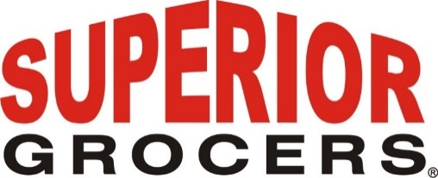

**Superior Grocers Announces Mary Kasper as Chief Legal and Human Resources Officer**

**Santa Fe Springs, CA (May 10, 2024)**- Superior Grocers proudly announces the appointment of Mary Kasper as the company's Chief Legal and Human Resources Officer. With an illustrious background in law and extensive experience in the retail sector, Kasper brings a wealth of knowledge and expertise to her new role.

Kasper joins Superior Grocers from 99 Cents Only Stores, where she served as Chief Legal Officer, General Counsel and Secretary. ’ Her previous executive positions at Unified Grocers and Fresh & Easy Neighborhood Markets further solidified her reputation as a trusted advisor and thought leader in the retail industry. Kasper also held leadership positions in the legal departments of Ralphs/Food 4 Less and Vons, where she provided strategic legal counsel to support business objectives.

Throughout her career, Kasper has been recognized for her outstanding contributions, including being named a finalist for the Los Angeles Business Journal Outstanding Corporate Counsel Award. She is an active member of prominent industry associations, including the California State Bar Association, Food Marketing Institute, and the California Grocers Association (CGA). Kasper previously served as the Chair of the CGA and CGA’s Government Relations Committee.

"We are thrilled to welcome Mary Kasper to Superior Grocers as our Chief Legal and Human Resources Officer," said Richard Wardwell, President and CEO at Superior Grocers. "Her extensive experience and proven track record of success will be instrumental in driving our human resources initiatives forward as we continue to prioritize the well-being and development of our employees and in providing legal and strategic guidance to the business."

Kasper holds a Juris Doctorate from the UCLA School of Law and a a B.A. in English, Phi Beta Kappa, magna cum laude from UCLA.

As Superior Grocers embarks on its next phase of growth and innovation, Ms. Kasper's leadership will play a pivotal role in nurturing a thriving and inclusive workplace culture.

**About Superior Grocers**

Superior Grocers is one of the largest independently owned chain of grocery stores in Southern California. Superior began its operations in 1981 with one store and has experienced steady growth for over 43 years. In 2022, Superior acquired Southern California grocery chain, Numero Uno. It now operates 73 stores throughout California and Nevada. Aside from its wide assortment of grocery, produce, meat, bakery, frozen, deli, international foods & general merchandise products, Superior stores also offer a variety of freshly prepared products in the Bakery, Meat & Seafood, Service Deli and Hot Foods departments.

It prides itself in providing Superior Quality, Superior Variety and Superior Value to the communities that it serves. Superior Grocers is a strong community partner and continually supports programs that help bring a positive impact to its customers, including education, health awareness efforts and many local youth organizations and non-profit groups. For more information about Superior Grocers, please visit [www.superiorgrocers.com](http://www.superiorgrocers.com).

For more information, please contact Dale Nakata at dnakata@superiorgrocers.com

**@SUPERIORGROCERS**

Image result for facebook png Image result for instagram png

**Visit Our Website**

**Superiorgrocers.com**