DHD Films Announces Appointment of Jim Hicks as Head of Strategy and Innovation
Dallas, Texas — Award-winning creative media firm DHD Films announces the appointment of brand and experiential industry veteran Jim Hicks as its Head of Strategy and Innovation.
Known for his cross-disciplinary leadership at the intersection of creative and business needs and his unconventional approach to the future of collaboration and audience engagement, Hicks will be responsible for delivering on the next era of creative expression, brand storytelling, and audience interaction for which DHD has become renowned. He will join the DHD leadership team, reporting to Chief Success Officer Hussain Manjee.
“We are thrilled to have Jim join our team as our Head of Strategy and Innovation. His track record of leading award-winning creative across multiple channels fits perfectly with our aim to help brands move their audiences,” said Hussain Manjee.
Jim was most recently EVP of Creative at event production agency TENCUE, where he led award-winning event and experiential creative efforts for global brands including Cisco, BMW, Dropbox, Meta, Google, Amgen, and Salesforce, among others.
“One of the things that makes me most excited about where we’re heading—as brands and institutions look for new ways to tell their stories—is the convergence of voices, perspectives, and technologies that allow new kinds of interaction, new kinds of participation, and new forms of expression to become authentic and robust parts of our shared cultural fabric. The ways of making ideas and points of view visible and sharable are opening up in amazing ways, and it’s incredibly vital that we also recognize and embrace the whys—the reasons our stories need to be told, and the power of being exposed to them—and that’s as true for brand stories trying to reach new customers as it is for individual human stories trying to be seen and heard in an increasingly noisy world,” said Hicks.
Prior to joining TENCUE in 2016, Hicks has, at one time or another over his career, been a CCO, a VP of strategy, a film and television director, software developer, visual designer, writer, animator, executive whisperer, campaign strategist, experiential designer, futurist, music producer, mentor, wilderness survival guide, and pizza delivery boy.
“Jim brings insatiable curiosity, inexhaustible problem-solving ingenuity, and a deep love of collaboration in service of helping individuals, audiences, and brands find their voices, tell their stories, and engage, inform, and empower others. This makes him a great fit as we embark on our 25th anniversary year,” said Shezad Manjee, third-generation filmmaker, Founder, and Creative Director of DHD Films.
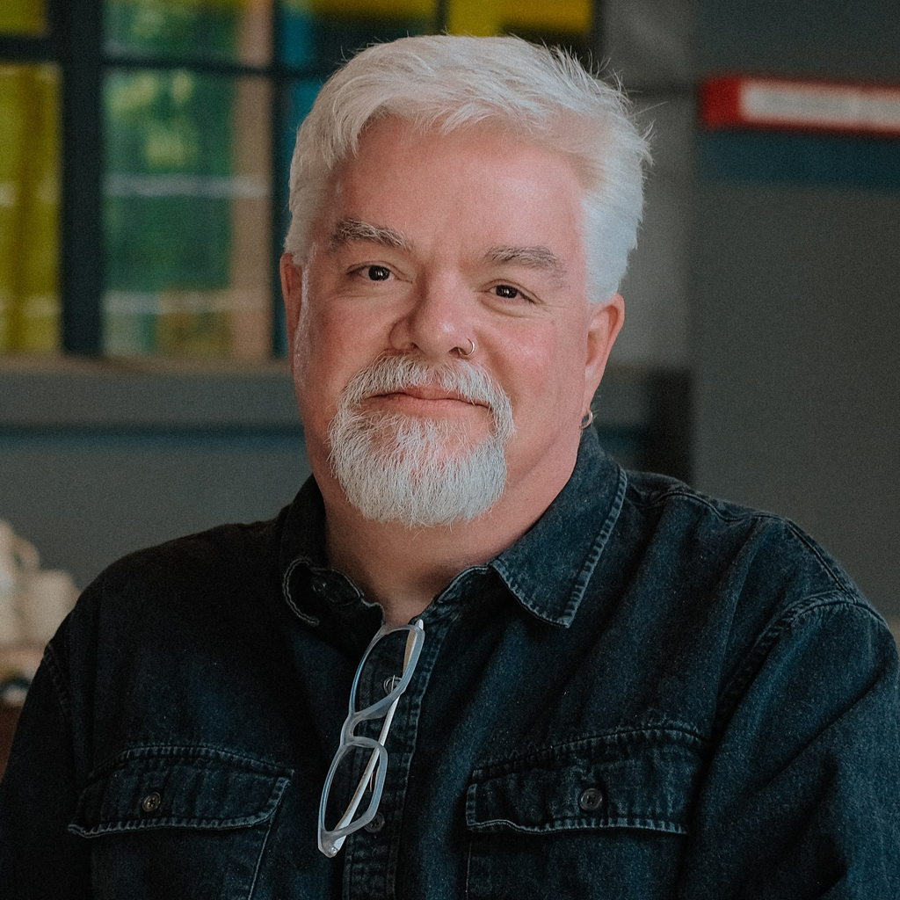
About DHD Films
DHD Films is an award-winning, full-service video production and motion graphics studio based in Dallas, Texas. We tell compelling stories designed to help build powerful brands. Our clients include Fortune 500 companies, innovative startups, and government and creative agencies. For more information, please visit dhdfilms.com OR checkout our sizzle reel at https://vimeo.com/828445634.

