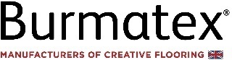


*MEDIA RELEASE Sept. 12th, 2024*
Introducing snowfall®, a new era of innovative colourful flooring featuring Thrive® matter yarn.
New snowfall® by Burmatex®, is a groundbreaking carpet tile that seamlessly blends innovative design with environmental responsibility. Crafted with Universal Fibers® Thrive® matter, certified carbon-negative recycled yarn, snowfall® takes its design inspiration from the undulating patterns made by snowfall.
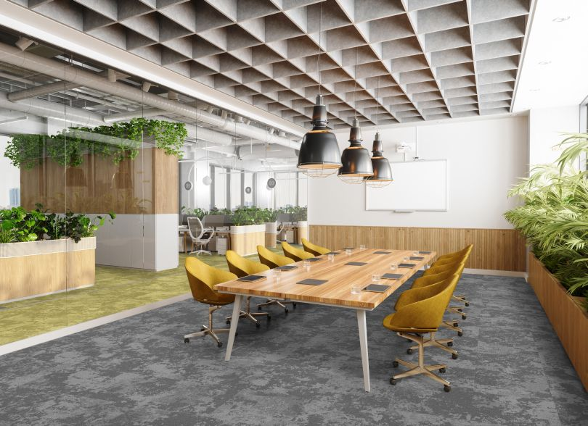
Thrive® matter stands alone as the most environmentally conscious solution-dyed, high-performance nylon fibres in the World. This, combined with Burmatex®’s unique BioBase® recycled backing, makes snowfall® a carbon-neutral product, setting a new standard for interiors.
Snowfall® offers an expansive and versatile colour palette with 16 shades, ranging from neutrals and contemporary greens to luminous peaches and icy blues. Each shade is carefully curated to reflect the natural beauty of winter landscapes, making it ideal for contemporary, trend-led workspaces that require both style and functionality.
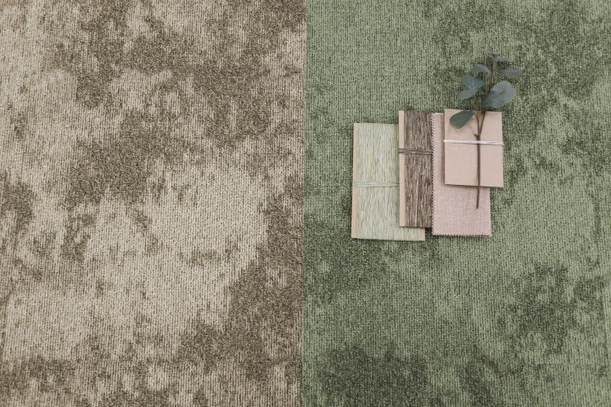
The versatile random-pattern-match design and beautiful colour palette makes it ideal for zoning different areas within an office, offering a practical solution for open-plan environments. Whether used to define collaborative spaces, quiet zones, or meeting areas, the snowfall® tiles can seamlessly adapt to various design needs.
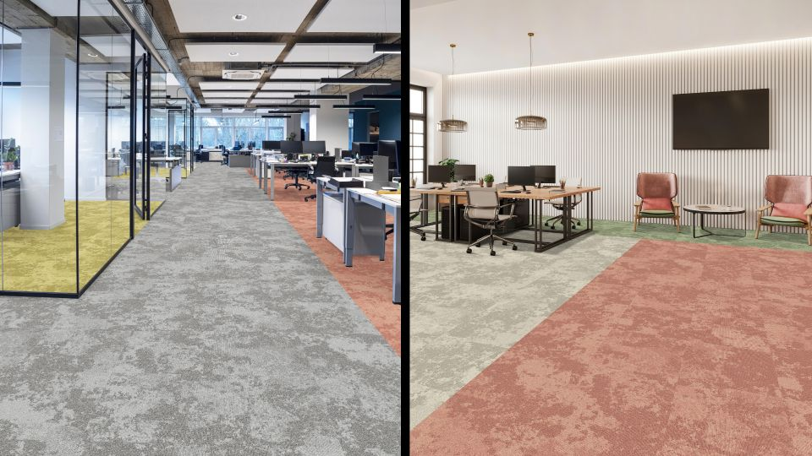
Burmatex® Designer, Holly, shares her insights on the snowfall® creative design process, “Snowfall® was born out of a desire to capture the understated elegance of snow patterns and the shadows they create. We wanted to develop a range that not only stands out visually but also provides versatility for various interior applications.”
Vivien, Burmatex® Head of Design, emphasises the importance of collaboration in the product’s development, “The more we work with Thrive® matter yarn from Universal Fibers®, the more we discover its incredible potential. Our collaboration with Universal Fibers® has been instrumental in pushing the boundaries of what’s possible in the development of sustainable flooring options.”
Anna Plumb, Vice President of European Sales and Marketing at Universal Fibers®, highlights the joint effort, “Snowfall® is a perfect example of what can be achieved when companies work closely together. By combining our yarn expertise with Burmatex®’s design vision, together we have created a sustainable product that not only meets our commitment to lowering embodied carbon but also delivers exceptional design and performance.”
Snowfall® is supported by Burmatex®’s comprehensive recovery take-back service - by partnering with local organizations, they find new homes for used carpet tiles, ensuring that they continue to serve a purpose within the community. By using the recovery take back service, you can ensure none of your used carpet tiles end up in landfill.
Simply put, snowfall® is a testament to sustainable workplace design innovation.

Editors Notes
About Universal Fibers®: Universal Fibers, Inc. is a business unit within Universal Fiber Systems, LLC. Based in Bristol, Virginia USA with global manufacturing facilities in Europe and China, Universal Fibers, Inc. is a global leader in the production of high quality, solution-dyed synthetic filament-based fibres for the flooring, transportation, and industrial fibres industries. We are leaders in technologies and practices that reduce water use and decrease emissions and embedded carbon. For more information, visit https://www.universalfibers.com/contact-us
About Burmatex®: Burmatex® is one of the UK’s leading manufacturers of carpet tiles and planks, specialising in sustainable, design-led solutions for commercial spaces. With a focus on innovation and sustainability, Burmatex® is dedicated to creating products that contribute positively to the environment and the communities they serve.
Press Contact
Jennifer Roundtree
Jennifer.Roundtree@universalfibers.com
Mobile: +1 4239636087

