
UNIVERSAL FIBERS® EXPANDS PARTNERSHIP WITH FORBO FLOORING SYSTEMS
Introducing Forbo’s New Tessera Topology Collection featuring Thrive® Matter Yarns.
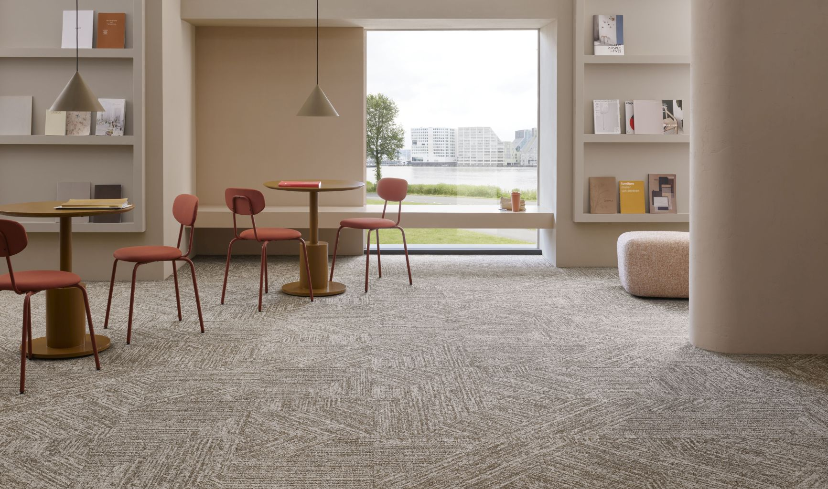
Universal Fibers are excited to announce the launch of Forbo Flooring Systems’ New Tessera Topology, the first collection in their Evolve+ series, using Thrive® matter yarn from Universal Fibers®.
Thrive® matter is the lowest carbon footprint yarn in the industry, made from 100% solution-dyed nylon 6 with 90% recycled content. This innovative yarn, paired with Forbo’s lean production processes, results in carpet tiles with over 75% recycled content and a very low embodied carbon (less than 1.5kg CO2 per square metre). The collection is manufactured in facilities using 100% renewable energy, including both electricity and biogas, reinforcing Forbo’s commitment to reducing environmental impact.
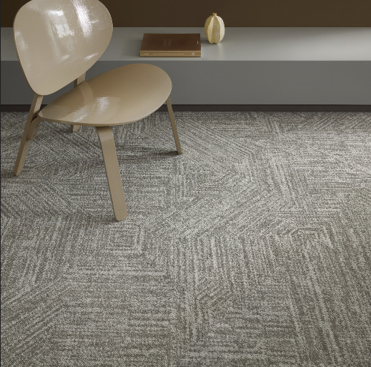
Donna Hannaway, Head of Marketing UK and Ireland at Forbo Flooring Systems said: "As a manufacturer, sustainability is extremely important to us at Forbo. Our core values are Renewability, Transparency and Circularity, and as such we’re always looking for ways to adapt and evolve our product portfolios in line with this, as well as to meet modern sustainability requirements. This means we are constantly developing new ways for architects and specifiers to incorporate environmentally friendly finishes into their projects, as with this new collection."

In addition to its environmental benefits, Tessera Topology offers a sophisticated, contemporary aesthetic. The collection features a geometric pattern that balances linear angles with organic textures, creating a unique and versatile design that brings warmth and character to any interior space. Designed and manufactured in the UK, Tessera Topology is available ex stock, making it ideal for office refurbishments and other fast-track projects. The collection also meets stringent indoor air quality standards, such as Indoor Air Comfort Gold and GUT certification, ensuring a healthier environment for end users.
Available in collection of beautiful neutral tones and muted accent, such as the subtle beige of Pebble Tangent and the earthy green of Willow Inverse, Tessera Topology provides an ideal solution for a wide range of projects. The tiles come in a standard 50x50cm format, so can be easily integrated with other products from Forbo’s existing Tessera range, offering endless design possibilities.
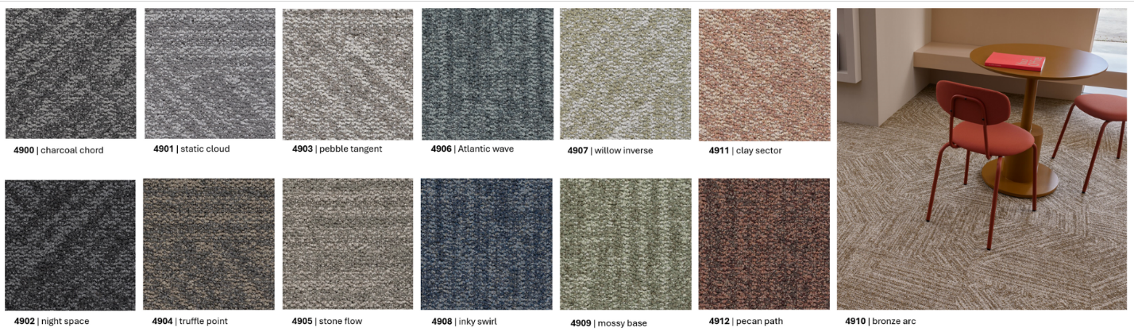
Forbo’s Tessera carpet tiles can be installed adhesive free using IOBAC MagTabs™, allowing them to be easily removed and reused or recycled, supporting a circular economy. Forbo is also proud to have recently entered into partnership with the Salvation Army Trading Company, supporting it’s Take Back scheme and furniture shops with donations of reusable carpet tiles.
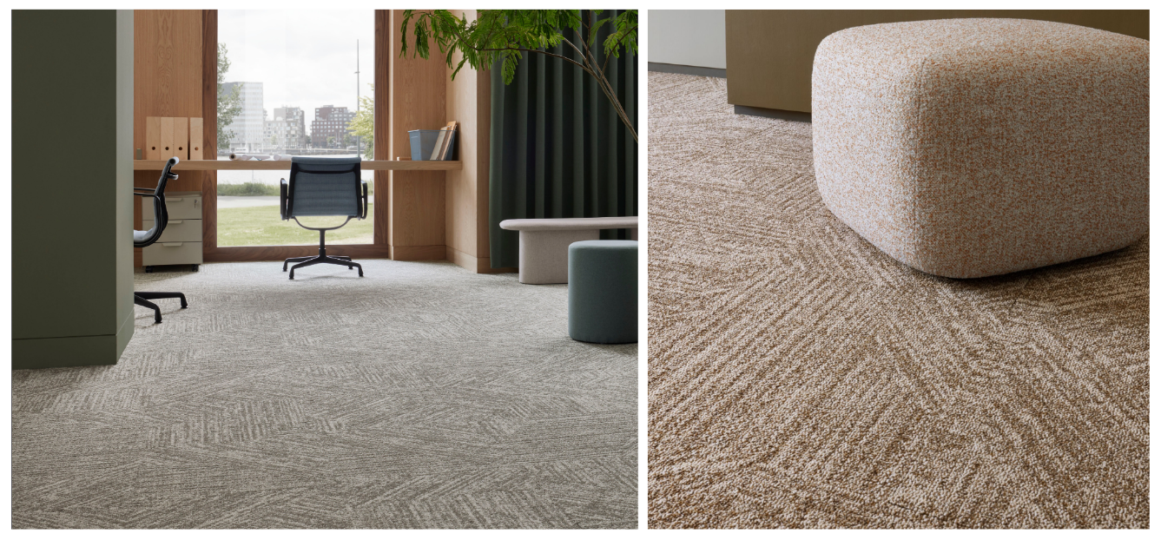
Universal Fibers are delighted that Tessera Topology marks a significant step forward in Forbo’s sustainability journey and is the first in the company’s Evolve+ series, a product line dedicated to enhanced sustainability and innovation in carpet tile manufacturing.
Phil Harmon, President of Universal Fibers, shared his thoughts on the collaboration: "Our work with Forbo has enabled the creation of an industry-leading product that aligns perfectly with the evolving demands of sustainability in the carpet tile industry. We are thrilled to see Thrive® matter, our most sustainable fibre yet, contribute to Forbo’s sustainable vision."

Editors Notes
About Universal Fibers®: Universal Fibers, Inc. is a business unit within Universal Fiber Systems, LLC. Based in Bristol, Virginia USA with global manufacturing facilities in Europe and China, Universal Fibers, Inc. is a global leader in the production of high quality, solution-dyed synthetic filament-based fibres for the flooring, transportation, and industrial fibres industries. We are leaders in technologies and practices that reduce water use and decrease emissions and embedded carbon. For more information, visit https://www.universalfibers.com/contact-us
About Forbo: Forbo Flooring Systems is a global provider of premium commercial and residential floor coverings. We have an extensive and attractive range of environmentally friendly linoleum, high-quality vinyl flooring & LVT, entrance flooring systems, carpet tiles, needlefelt and Flotex flocked flooring. For more information on the Tessera Topology collection, visit: www.forbo-flooring.co.uk/topology

Press Contact
Jennifer Roundtree
Jennifer.Roundtree@universalfibers.com
Mobile: +1 4239636087

