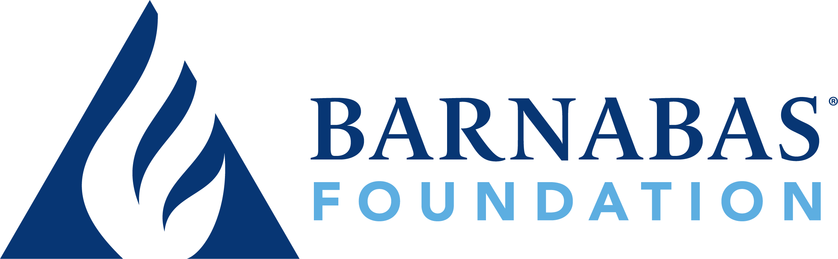
FOR IMMEDIATE RELEASE
New Release! Money and Spirit: Surrendering Our Finances to the Work of the Holy Spirit

Barnabas Foundation announces the upcoming release of Money and Spirit: Surrendering Our Finances to the Work of the Holy Spirit. A biblically grounded study on the intersection of faith and finances, Money and Spirit is designed to be a practical resource for individuals, couples, and small groups.

Christian Leadership Alliance’s Outcomes Magazine named Money and Spirit one of its "must-read” new releases for Christian leaders.

Ken Blanchard, bestselling co-author of The New One Minute Manager and Simple Truths of Leadership, has also endorsed new-coming author Heather M. Day’s book.

"Heather uses transparency, humor, and biblical insight to present a message of hope for all," said Blanchard.

Each chapter of Money and Spirit includes an in-depth exploration of the fruit of the Spirit (as listed in Galatians 5), stories from real people who have experienced financial transformation, reflection questions and journaling space, and guided prayers. The book also includes small group discussion questions and access to online teaching videos.

Heather M. Day is an author and communication specialist with more than 20 years of experience in marketing, communications, and nonprofit ministry. She’s spent the bulk of her career in the nonprofit arena, including in her current role as director of marketing for Barnabas Foundation. She holds a bachelor’s degree in communications and an executive MBA from Olivet Nazarene University.

Money and Spirit will be released in bookstores on January 21, 2025, and is now available for pre-sale from all major online retailers. Learn more and order at MoneySpirit.org.

###
Further Information and Interview Booking: MEDIA KIT
Heather Day, Director of Marketing
hday@BarnabasFoundation.org / 888.448.3040

