

FOR IMMEDIATE RELEASE
Thursday, March 27, 2025

UNIVERSAL FIBER SYSTEMS EXPANDS THEIR MARKET LEADERSHIP BY WELCOMING FIT AS THEIR LATEST ACQUISITION.
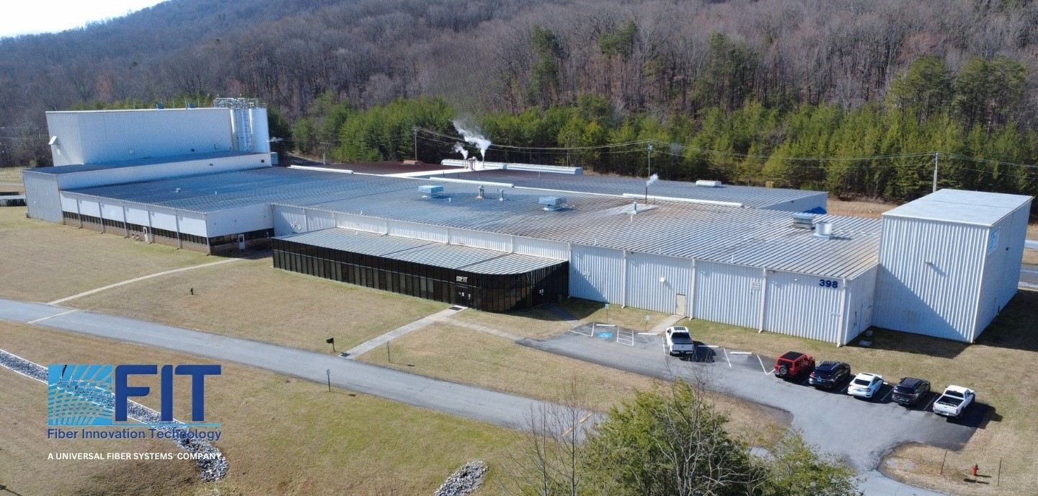
Figure 1: Arial image of FIT in Johnson City, TN, recently acquired by Universal Fiber Systems
Johnson City, Tennessee, March 27, 2025 – Universal Fibers, Inc. is pleased to announce the latest addition to the Universal Fiber Systems portfolio, FIT. Known as a leader in fiber technology, FIT (formerly known as Fiber Innovation Technology) is now a part of Universal Fiber Systems. This latest investment in Johnson City, Tennessee, represents a strategic expansion of Universal Fiber Systems capabilities and commitment to innovation and customer service to our expanding global market, now serving twenty-two diverse segments.
"We're thrilled to add FIT to Universal Fiber Systems! I've long admired FIT and am impressed with what Chris Parris and his team have accomplished," said Marc Ammen, CEO of Universal Fiber Systems. "We will be supporting FIT by expanding its production capacity in the very near future to continue advancing our market leadership."
FIT, known for its cutting-edge approach to fiber solutions, has been at the forefront of technological innovations in the industry. "FIT and I are very excited to join the Universal Fiber Systems' team," remarked Chris Parris, General Manager of FIT. "We look forward to the new growth this venture will bring, and continuing our tradition of innovation, expertise, and unparalleled customer service, now under the Universal Fiber Systems umbrella."
This acquisition underscores Universal Fiber Systems' dedication to enhancing its product offerings and service capabilities. The integration of FIT into Universal Fiber Systems not only expands its operational footprint but also enriches its technical prowess and response to market needs.
"Adding FIT's innovative capabilities and expert team to our portfolio enhances our ability to serve and respond to our customers more effectively," added Ammen. "It ensures we remain at the cutting edge of fiber technology and continue to push boundaries in the ever-evolving industries we serve."
The partnership marks a significant step in Universal Fiber Systems' strategy to lead the industry in sustainable, high-performance fiber solutions while diversifying our portfolio in fiber technology, empowering both Universal Fiber Systems and FIT to better serve global customers with enhanced products and services.

Editors Notes
About Universal Fiber Systems: Universal Fiber SystemsSM LLC. is an innovation-driven global leader with a family of brands specializing in the production of high-quality synthetic fibers for a broad array of applications and industries. Serving customers in the production of the flooring, industrial, military, medical and apparel industries, you will find fiber products manufactured by Their companies in most major brands and prominent projects around the world. For more information, please contact info@universalfibers.com
About FIT: Located in Johnson City, Tennessee, FIT (formerly Fiber Innovation Technology) specializes in the design and production of specialty synthetic fibers for advanced applications in textiles and nonwovens. Our state-of-the-art facilities include a world-scale production line and a dedicated semi-works facility for product development. Our team, comprising industry veterans with extensive experience, drives our commitment to innovation in fiber technology. FIT offers a wide range of capabilities, from developing bicomponent fibers to custom solutions tailored to meet specific customer needs. We pride ourselves on turning innovative ideas into reality, supporting customers from concept through to execution. For more information about our capabilities and how we can assist with your specialty fiber requirements, please visit www.fitfibers.com

Press Contact
Jennifer Roundtree
Jennifer.Roundtree@universalfibers.com
Mobile: +1 4239636087

