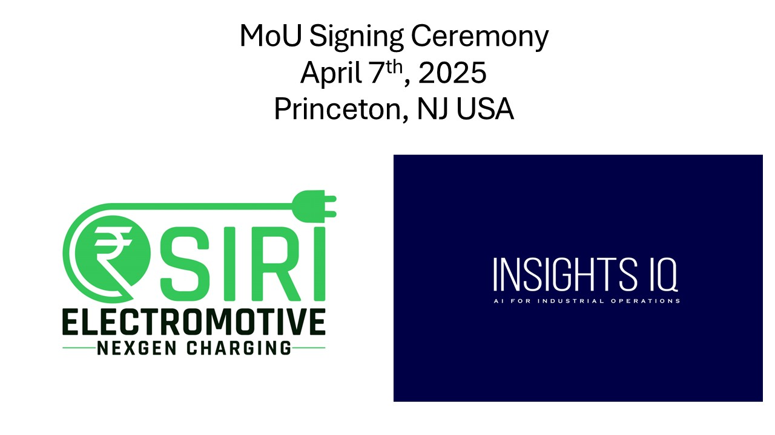

InsightsIQ and SIRIEM Sign MoU to Drive AI-Powered Innovation in EV Charging Monitoring

Princeton, NJ – April 7, 2025
In a significant step toward advancing AI-driven sustainable energy solutions, InsightsIQ and SIRI Electromotive have signed a Memorandum of Understanding (MoU) to collaborate on the development of an AI-powered electric vehicle (EV) charging infrastructure digital monitoring platform. The signing ceremony took place in Princeton, NJ, marking the beginning of a strategic partnership aimed at revolutionizing the EV industry through AI-powered analytics and real-time data integration.
Currently, there is no comprehensive system or product in the global market that can collect granular and real-time charger data from EV chargers. Under this partnership, InsightsIQ will develop a digital AI-powered monitoring platform for EV charging to complement the predictive maintenance module developed by SIRI Electromotive. By leveraging proactive predictive maintenance, intelligent efficiency optimization and real time monitoring, the two companies aim to optimize energy consumption, reduce downtime and improve the overall EV charging experience for consumers and businesses alike.
InsightsIQ is a leader in AI for industrial operations having expertise in data-driven analytics, machine learning, and real-time anomaly detection.
SIRI Electromotive is a charge-tech company focused on the manufacture of high quality and future ready EV chargers, among other charging related products. It’s proprietary technology stack enables design and manufacture of AC and DC chargers, including all core sub-assemblies, conforming to global standards.
"This MoU signifies a critical step forward in merging AI with sustainable energy solutions," said Vikram Gupta, CEO of InsightsIQ. "By combining our AI-driven industrial analytics and agentic Industrial Data Warehouse(IDW) with SIRI Electromotive’s innovative charging technology, we are setting the foundation for a smarter, more efficient, and scalable EV charging monitoring ecosystem."
Satish Shenoy, Founder and CEO of SIRI Electromotive, added: "Our collaboration with InsightsIQ will accelerate the integration of AI into any charging infrastructure, enabling us to offer proactive maintenance and predictive analytics for monitoring and control. Together, we are committed to contributing to the future of sustainable mobility."
The partnership aligns with the growing demand for EV Infrastructure monitoring and data analytics where AI will play a crucial role in energy demand management, in predicting failures before they occur and for integration with smart grids.
The MoU signing ceremony was attended by industry leaders, technology experts, and local officials, underscoring the importance of this partnership in shaping the future of AI-driven sustainable energy.

For more information about this collaboration, please contact:
Media Contact:
Vikram Gupta
Vikram.gupta@insightsIQ.us
https://www.insightsIQ.us

