Sosai Renewable Energies 2025 Ashden Awards Breaking Barriers Global South press release

Dear media colleague
Please find a press release below regarding the announcement of Sosai Renewable Energies as a winner of the 2025 Ashden Award for Breaking Barriers.
Please note that photos below are placement only, high res photos can be downloaded from the links in Notes to Editors.
If you would like an interview or op-ed from Habiba Ali, Sosai’s CEO and Founder, please get in touch.
Yours.
Habiba Ali
habiba@sosairen.org
+2348033110130

PRESS RELEASE
‘For Immediate Release’
Sosai Renewable Energies Nigeria wins global Ashden Award for low carbon innovation As a Pioneer Breaking Barriers Winner for Global South
Sosai Renewable Energies (“Sosai”) has won a prestigious Ashden Award for its outstanding workrenewable energy technologies that provide off-grid energy solutions to communities and businesses in rural northern Nigeria, such as solar home units, solar mini grids,working as Climate Smart Villages and solar for productive use.
Winners of the 2025 Ashden Awards were revealed at the Royal Geographical Society in London on June 11.
Every year, the Ashden Awards showcase inclusive climate solutions - work that creates a fairer and more prosperous world, as well as lowering emissions and preparing communities for climate threats. This year Sosai Renewable Energies won the 2025 Ashden Award for Breaking Barriers (Global South), sponsored by Next Energy Foundation. The organisation was revealed as one of six winners at a special 25th Anniversary Ashden Awards ceremony.
All winners were chosen for their exemplary work on clean energy in either the UK or the Global South. The Awards honoured innovators from the private and non-profit sectors.
Speakers at the London ceremony included UK Climate Envoy Rachel Kyte, and Ugandan environmentalist Vanessa Nakate. The host was BBC World Service presenter Myra Anubi.

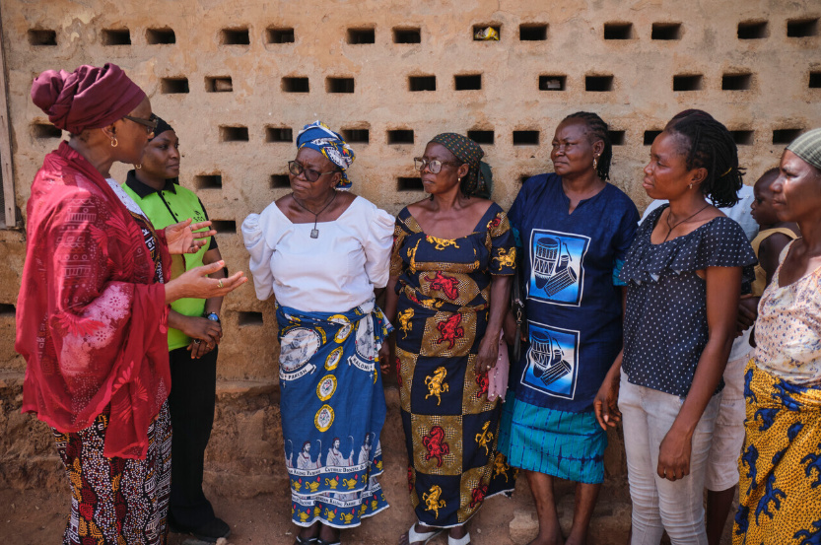
Photo: Habiba Ali, Founder of Sosai, with village women representatives from Shendam Local Government Area of Plateau State. Sosai powers the Kalong community through its innovative 'Climate Smart Village' mini-grid system. Sosai has deployed renewable energy solutions to over 2 million Nigerians especially in rural communities of Nigeria ranging from solar home systems, mini grids and solar powered productive use Technologies. Credit: Emeke Obanor/Ashden

Sosai distributes low-cost, high-impact technologies. So far, the company has sold over 25,000 solar products, deployed 5 mini-grids for productive use and impacted over 1,500,000 lives across 200+ communities. Sosai’s goal is to ensure sustainable development for communities by deploying renewable energy products that create economic growth and positively impact rural lives.
The Nigerian off-grid market has evolved from a nascent sector to an emerging sector. This growth is driven by an enormous untapped solar energy potential with high demand for electricity and low levels of installed capacity to serve an energy access gap of ~75% of Nigerians currently unserved or underserved by the national grid.
Northern Nigeria has the highest solar potential compared to the rest of the country but also has the lowest energy access rates creating a significant opportunity.
Sosai can bridge the energy gap and balance the energy deficit in disadvantaged societies through micro-grids, mini-grids, and solar home and business solutions which have been identified as a cost-effective means of electrification for over 48 million Nigerians.
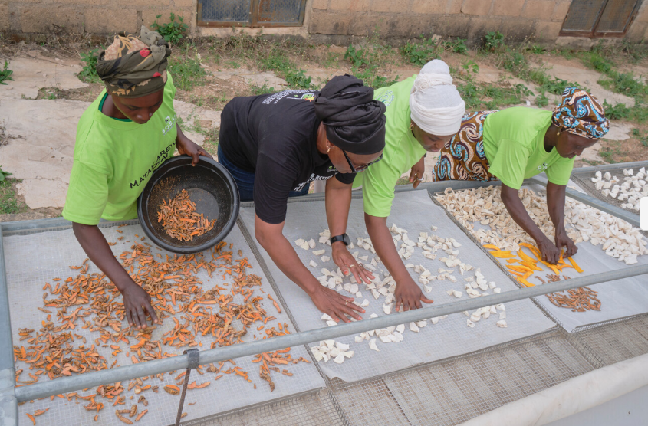
Photo: The Kwoi agro-processing group using a solar powered agricultural dryer which greatly reduces drying time, trained by Sosai Renewable Energies in Jaba Local Government Area of Kaduna State. Credit: Emeke Obanor/Ashden

Habiba Ali, Sosai’s CEO was in London to receive the awardshared that: “ I was amazed at the opportunity of winning this award and being on stage to collect it surrounded by my family. I felt fulfilled and knew that the work has just begun and I look forward to what this award will unlock for our future.”
In her acceptance speech Ms Ali spoke about the multitude of women Sosai support providing solar powered technologies to run their businesses.
She spoke about Karime who is taking care of herself after her husband passed away with her five children and her husband’s other wife and her 2 children from the proceeds she makes using the Solare freezer in Baawa, Kaduna State
This year’s winners were chosen by panels of independent judges. These panels included entrepreneurs, investors, academics, civil society leaders, journalists and campaigners.
As the winner of the 2025 Ashden Award for Breaking Barriers (Global South), Sosai Renewable Energies will receive promotion and connection to funders, investors, policymakers and climate sector leaders. The organisation will also receive a grant of £25,000/ N 52,000,000
Ashden CEO Dr Ashok Sinha said:
“The 2025 Ashden Award winners are setting us on course for fairer, greener, better future. These are proven solutions with enormous impact, led by true climate pioneers. In Ashden’s 25th year, we are delighted to celebrate these inclusive and inspiring champions.
“In today’s turbulent world, our winners are illuminating the way forward - improving lives as well as slashing carbon emissions by creating new jobs, cutting energy bills, improving health and building stronger communities. Congratulations to every one of them.”
The celebration also took place during Great Big Green Week in the UK - the UK’s biggest celebration of action to tackle climate change and protect nature, and ahead of London Climate Action Week, also in June.
The six 2025 Ashden Award winners
Three winners have been awarded for their work powering clean energy in Africa and India, and three for their work supporting clean community energy and energy-efficient homes in the UK. The headline sponsor of the 2025 Ashden Awards is Linkedin, and other sponsors include Downing, The Linbury Trust, The Waterloo Foundation and The Mark Leonard Trust. The knowledge partner is BloombergNEF.
All Global South winners:
- 2025 Ashden Award for Outstanding Achievement: BURN Manufacturing, Kenya (operating Africa-wide) – BURN’s efficient and affordable cookstoves have protected the health of 28 million people, while also reducing household fuel costs, emissions and deforestation.
- 2025 Ashden Award for Outstanding Achievement: SELCO, India – SELCO’s products and support have brought solar energy to households, small businesses and hospitals. With solutions tailored to the needs marginalised communities, its impact has reached at least 8 million people.
- 2025 Ashden Award for Breaking Barriers (Global South), supported by Next Energy Foundation: Sosai Renewable Energies, Nigeria – Sosai supports women to become clean energy entrepreneurs, with solar minigrids and work to break down gender barriers.
Winners in the UK included: Repowering London - transforming clean community energy in London; Cotality (formerly Parity Projects) – helping housing providers and homeowners create warm, energy efficient homes; and Emergent Energy – generating energy and financial savings through rooftop solar.
Watch and read more about Sosai’s work and 2025 Ashden Award https://ashden.org/awards/winners/sosai-renewable-energies/
ENDS
NOTES TO EDITORS
- Press contact :
Sosai Renewable Energies , Habiba Ali, habiba@sosairen.org +2348033110130
2. About Sosai Renewable Energies :
Habiba Ali founded Sosai Renewable Energies and has been working in the renewable energy industry since 2005. Sosai has deployed renewable energy solutions to over 2 million Nigerians especially in rural communities of Nigeria ranging from Solar Home Systems, Mini Grids and Solar Powered Productive Use of Energy Technologies. Habiba has won accolades like Global Leadership Award in Economic Empowerment for the work she does in Empowering Rural women to own businesses in Renewable Energies, UNSDG WeEmpower Winner for Africa and the Global Prize, as well as others. Habiba is an Acumen Fellow, Perennial Fellow, OXFAM/EDC WIP graduante and currently the country Chairperson of African Women in Energy and Power.

- Ashden Press Lead sue.wheat@ashden.org Mob. +44 (0)7950 953004 or Craig.Burnett@ashden.org Web: https://ashden.org/awards/ Instagram . LinkedIn . YouTube .

- Ashden Awards Media Pack - see Ashden Awards media pack for project summaries of Global South Winners media pack
Habiba Ali’s Ashden Awards acceptance speech
Spokesperson bios from Ashden and winners.
Ashden spokespeople bios - Ashden’s CEO Dr Ashok Sinha and other specialists within Ashden are available for interview on UK and Global South clean energy issues.

- Sosai Renewable Energies spokesperson Habiba Ali is available for interview after the Awards on Zoom, or in-person.
Bio:
She possesses a Bachelor’s degree in Accounting, A master’s in Banking and Finance and currently at Dissertation level of PhD in Management (Finance). She has also acquired trainings entrepreneurship at EDC, Like Road to Women’s Business Growth and the WomenX (CEM) program as well as trainings in Energy and Environment like, Energy for Sustainable Development: University of Lund Sweden, Gender in Energy and Environment: Energia, Formulating proposals for CDM Projects: University of Twente, Netherlands and others.
A broadcast quality 2-3 min film of Sosai Renwable Energies is on Ashden’s website and YouTube channel. Clean B-roll footage is available on request - contact jon.spaull@ashden.org and sue.wheat@ashden.org

- Film footage of interviews with people benefitting from Sosai’s work can be shared on request to Ashden.

- High-res photos can be downloaded from here: Sosai photo gallery link

