FOR IMMEDIATE RELEASE June 15, 2025

UNIVERSAL FIBERS® AND CIRCULAR BUILDING SOLUTIONS JOIN FORCES ON ACCELERATING FLOORING CIRCULARITY
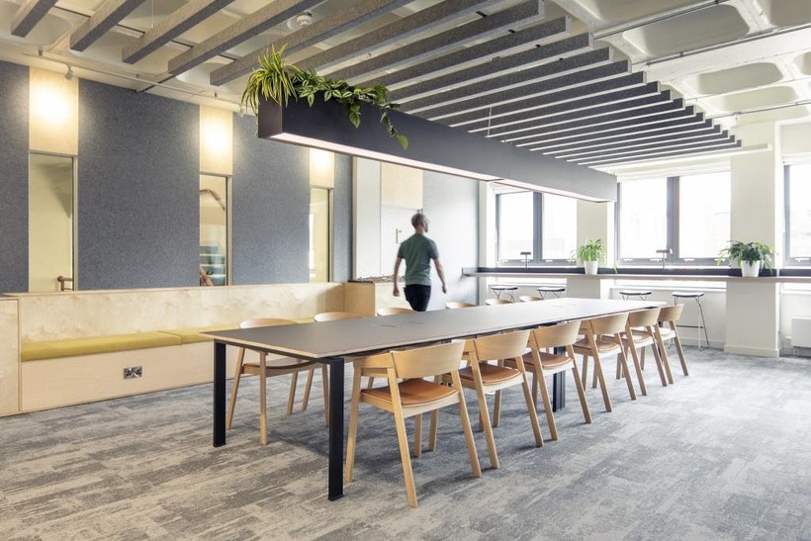
Photo: Bond Bryan featuring arctic® flooring by Burmatex®, installed using adhesive-free IOBAC MagTabs

With demand growing for more sustainable, circular floor covering solutions, global fibre leader Universal Fibers® has announced its endorsement of Circular Building Solutions’ adhesive-free, reversible fixing technologies.
The two companies are joining forces to highlight the critical role that holistic thinking plays in enabling flooring manufacturers to enhance the circularity of their products.
For over 50 years, Universal Fibers has pioneered sustainable practices in the production of high- performance carpet fibres, including the introduction of its innovative Thrive® matter yarn, the world’s first carbon negative recycled yarn. Thrive matter is the lowest carbon footprint yarn in the industry, made from 100% solution-dyed nylon 6 resin with 90% total recycled content.
Circular Building Solutions’ fixing systems complement this by offering a reversible, adhesive-free alternative to traditional installation methods. Their solutions enable floor coverings to be securely installed throughout a project’s life - yet easily lifted at end-of-life for easier reuse or recycling. This approach supports material circularity, reduced waste and protects valuable sub-floor assets.

With specifiers increasingly recognising the commercial and environmental benefits of designing for disassembly, detachable fixing methods are rapidly gaining traction across the UK, Europe, Australia and the US.
A Collaborative Approach
Ian Spreadborough, co-founder of Circular Building Solutions Ltd, explains: ”A truly circular flooring solution must consider the total flooring assembly, from the sub-floor to the fixing mechanism to the individual materials within a floor covering such as the backing and yarn.
We are proud to collaborate with Universal Fibers to promote how a holistic approach to flooring can deliver meaningful sustainability gains. With shared partnerships already in place with manufacturers such as Forbo, Milliken™, Burmatex® and Balsan, we look forward to driving broader industry change together.”
Anna Plumb, VP European Sales and Marketing at Universal Fibers adds, “Our ‘You First™’ commitment is a promise to our customers that we will continue to innovate unique fibres and finishes that ensure our customers can develop sustainable, high-quality products with confidence.
Supporting products designed for disassembly through reversible fixings is another way to continue diverting carpet waste from landfills, and we’re excited to formalise our support for Circular Building Solutions and to work together in promoting the transition to a more holistic approach to circularity with future-ready flooring systems.”
More info at www.circularbuildingsolutions.co.uk I http://www.universalfibers.com

About Circular Building Solutions Ltd
Circular Building Solutions specialise in modular and reversible commercial interior solutions aimed at promoting material reuse, protecting building assets and reducing waste, embodied carbon and costs. We offer consultancy services, product promotion, and circular service models to support the implementation of the circular economy in the built environment. Explore more at www.circularbuildingsolutions.co.uk.

About Universal Fibers®
Universal Fibers, Inc. is a business unit within Universal Fiber Systems, LLC. Based in Bristol, Virginia USA with global manufacturing facilities in Europe, China, and Japan, Universal Fibers, Inc. is a global leader in the production of high quality, solution-dyed synthetic filament-based fibres for the flooring, transportation, and industrial fibres industries. We are leaders in technologies and practices that reduce water use and decrease emissions and embedded carbon. For more information, visit https://www.universalfibers.com/contact-us

MEDIA ENQUIRIES
For more information, please contact:
Universal Fibers, Inc. - Jennifer Roundtree, Global Director of Marketing & Brands, email: jennifer.roundtree@universalfibers.com
Circular Building Solutions Ltd - Vikki Randles, Fresh Perspective Marketing Ltd, email: vikki@freshperspect.co.uk

