Contact:
Dale Nakata
Superior Grocers
562-345-9000
dnakata@superiorgrocers.com

SUPERIOR GROCERS OPENS ITS SECOND LAS VEGAS STORE

- New store at 390 S Decatur Blvd marks the 74th store for one of the nation’s largest independent grocery chains.
- Grand opening celebration on July 23 underscores the company’s commitment to investing in local communities, with planned check giveaways to local schools and organizations.

SANTA FE SPRINGS, Calif. (July 23, 2025) – Superior Grocers, a leading name in the grocery industry, announced today it has opened its second store in Las Vegas at 390 S Decatur Blvd. The expansion marks a significant milestone for the brand as it proudly opens its doors in Central West Las Vegas and welcomes a new community of diverse local shoppers to its 74th store.

Las Vegas customers can look forward to many of their favorite products, including a $1.99 street hot dog + Jarritos soda combo, premium cuts of SR Superior Ranch Meat, agua frescas, boba tea, fresh tamales, and treats from an in-store dulceria.

For fresh ingredients and savings, customers can visit SuperiorGrocers.com or download the mobile app for weekly deals in digital coupons.

Founded in 1981, Superior Grocers isn’t just a grocery chain; it’s a cornerstone of communities stretching from the Southland to the Central Valley in California, to Las Vegas, Nevada, with an unwavering commitment to provide superior quality, variety, and value. Over the last 43 years, the company has planted deep roots in the communities it serves. Through partnerships with educational initiatives, health awareness programs, and support for local youth organizations and nonprofits, Superior Grocers aims to make a real difference in its customers’ lives.

“Grocery stores are more than a place to shop; they’re a neighborhood hub. We believe great service, quality, and ingredients should be accessible to all, and we are proud of our reputation for delivering consistency and value. We are thrilled to open our second store in Las Vegas and look forward to building new, lasting relationships,” said Richard Wardwell, President and CEO of Superior Grocers.

Situated on Decatur Blvd just south of Highway 11, Superior Grocers is centrally located next to the well-known Opportunity Village Thrift Store and a short distance from several neighborhood restaurants, shops, banks, and gyms. The 36,888-square-foot store offers thousands of items across its departments to cater to the diverse needs of the community:

- Produce: A vibrant assortment of locally sourced and fresh produce.
- SR Superior Ranch Meats: Premium cuts of meat, ensuring the highest quality for every meal.
- Bakery: Freshly baked bread, pastries, and hand-crafted desserts.
- Tamales: Made with 100% fresh stone-ground nixtamal to bring authentic flavor to every bite.
- Prepared Foods: Freshly prepared meals and dishes, providing convenient options for every occasion.
- Grocery: Stocked with an extensive range of pantry staples, international products, and specialty items to meet every household’s needs.
- Tortilleria: Fresh, handcrafted tortillas add a touch of authenticity to every meal.
- Boba: Refreshing bubble tea drinks available in a variety of flavors.

Grand Opening Information and Hours of Operation
Superior Grocers will open today, Wednesday, July 23, at 9 am and mark the event with a ribbon cutting and check giveaway to Red Rock Elementary School, Griffith Elementary School, and Grupo Folklorico Libertad. Customers can enter a drawing for a chance to win a new Nissan Sentra, enjoy live entertainment, and sample fun food and drinks in a festive atmosphere.

The store is open 6 a.m. - 11 p.m. daily.

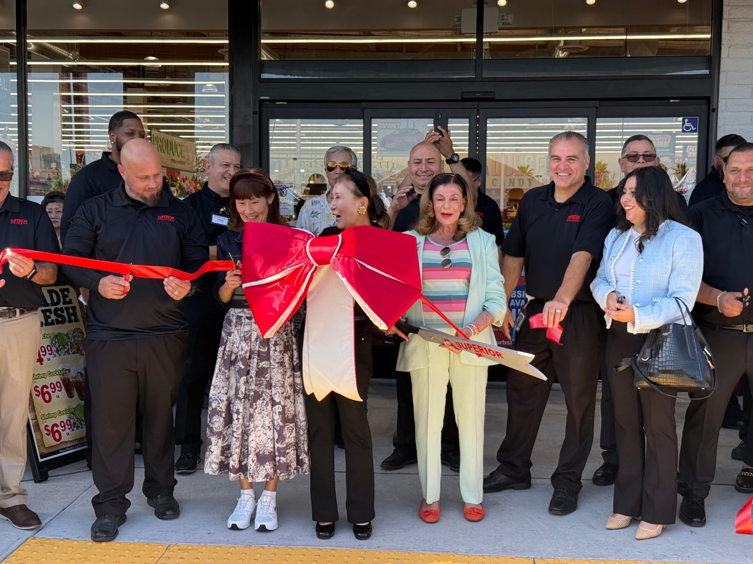

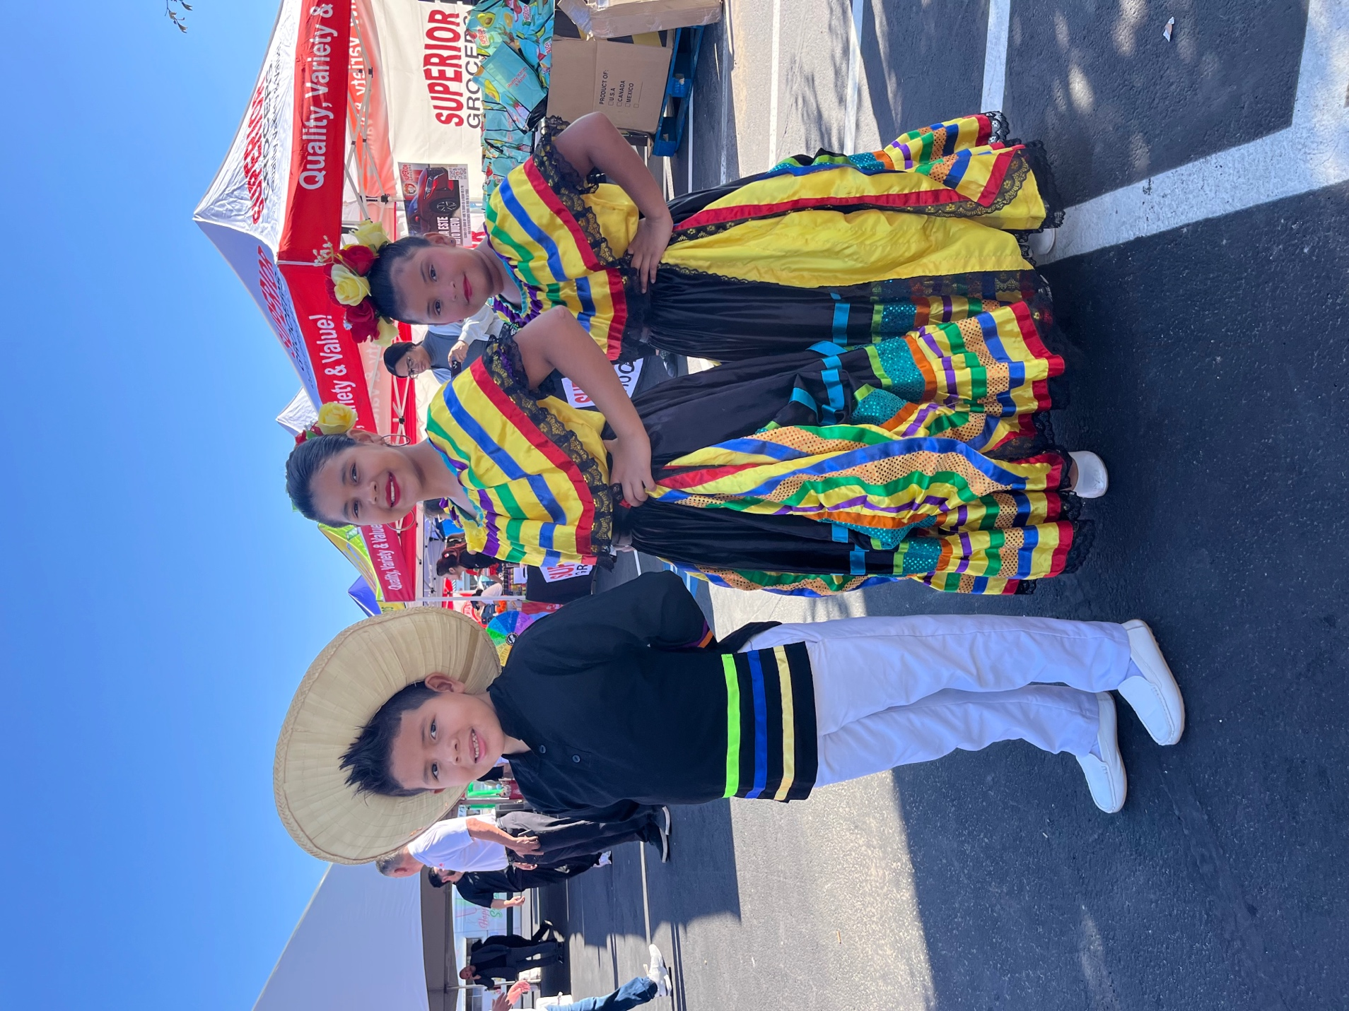

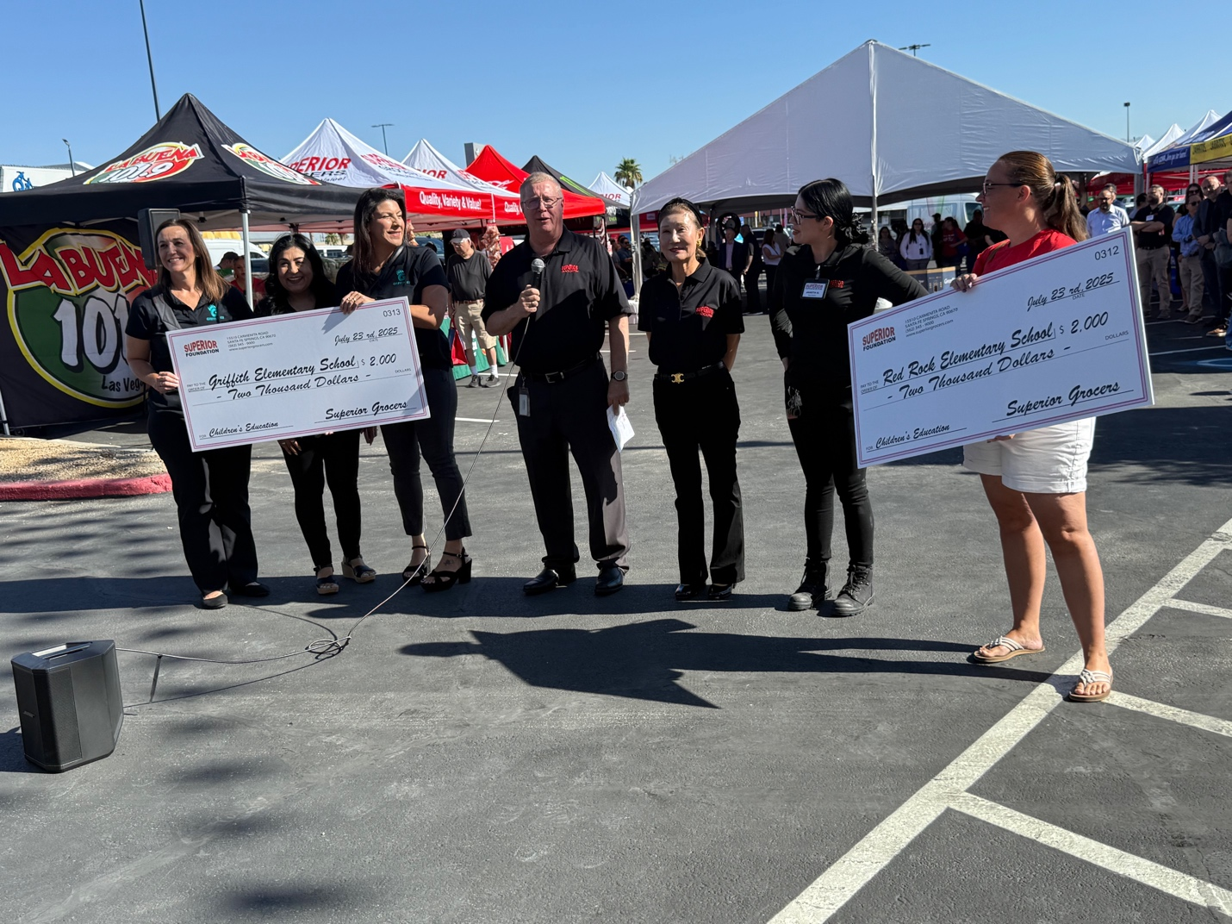

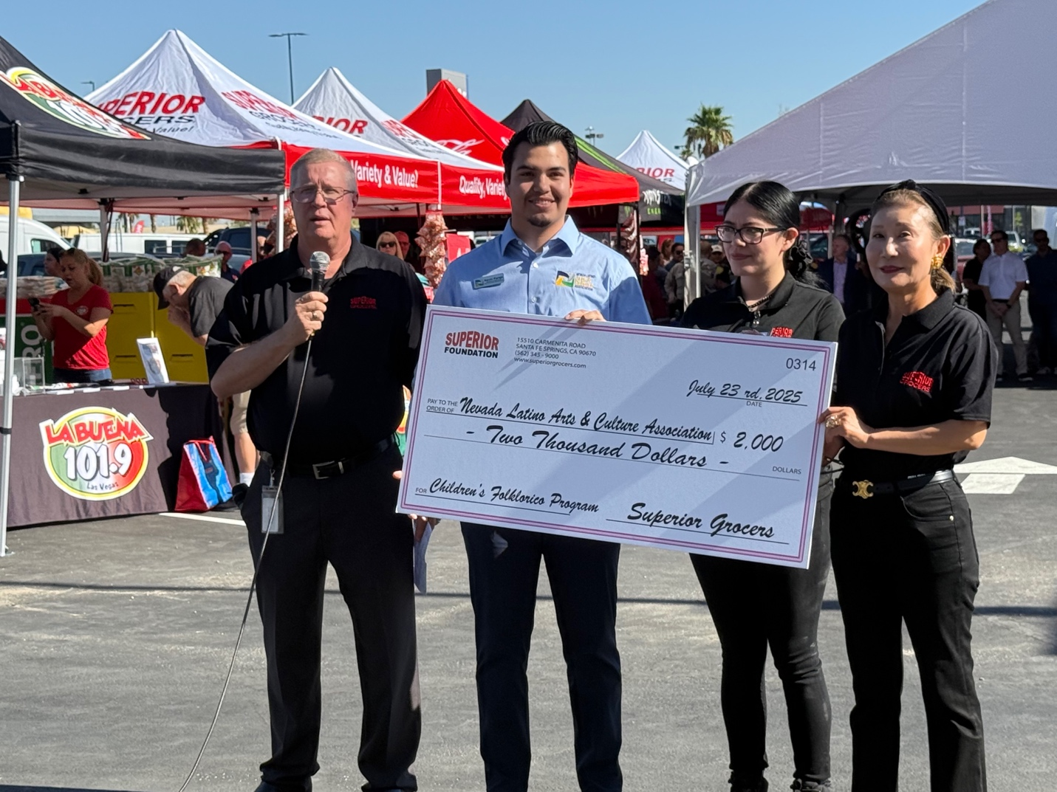

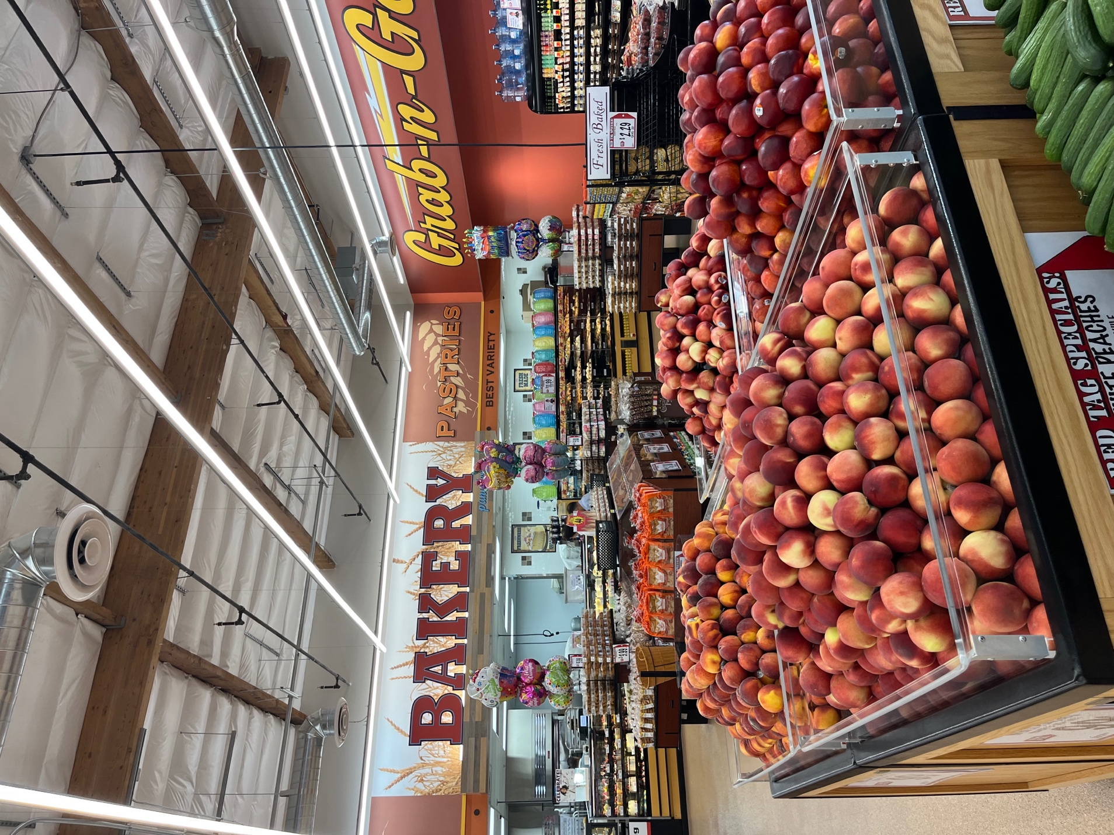
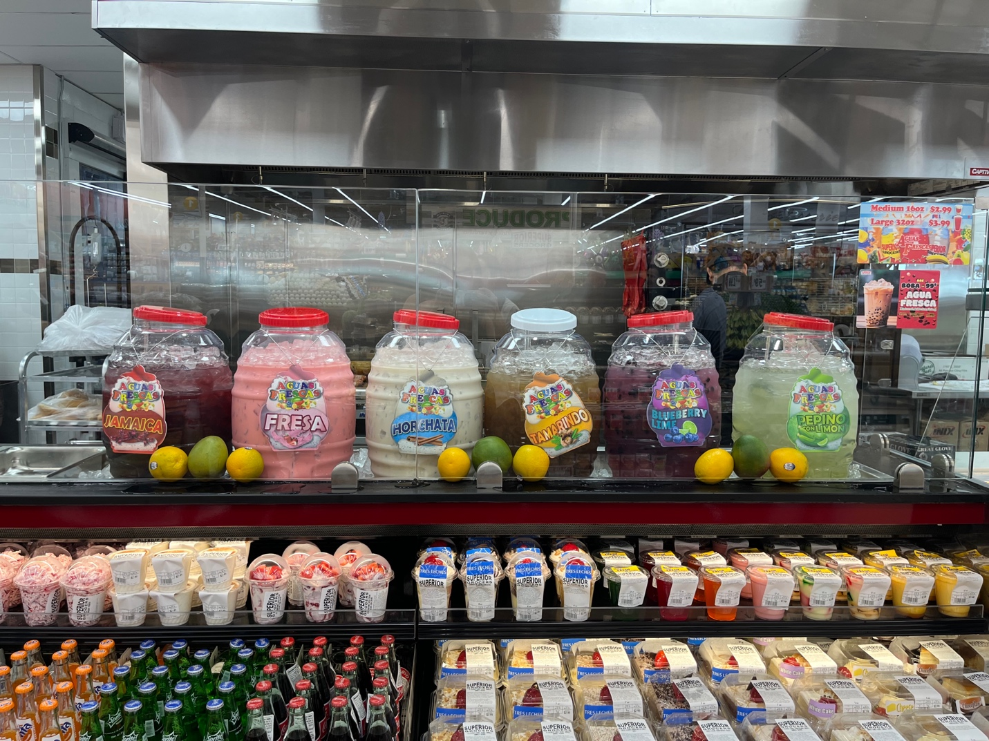

About Superior Grocers
Since opening its first store in 1981, Superior Grocers has grown into one of the largest independently-owned grocery chains in California and Nevada, with 74 locations and nearly 6,500 dedicated associates. Aside from its wide assortment of grocery, produce, meat, bakery, frozen, deli, international foods & general merchandise products, Superior stores also offer a variety of freshly prepared products in the Bakery, Meat & Seafood, Service Deli and Hot Foods departments.
It prides itself in providing Superior Quality, Superior Variety and Superior Value to the communities that it serves. Superior Grocers is a strong community partner and continually supports programs that help bring a positive impact to its customers, including education, health awareness efforts and many local youth organizations and non-profit groups. For more information about Superior Grocers, please visit www.superiorgrocers.com.

