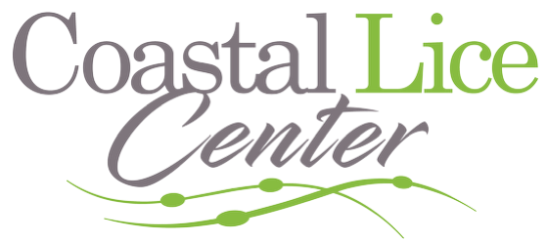

FOR IMMEDIATE RELEASE
Contact:
Coastal Lice Center
Phone: 843-421-7011
Email: tom@collinscompanyadv.com
Website: www.coastallicecenter.com

September is Head Lice Awareness Month
Coastal Lice Center Offers FREE Head Checks for Teachers
Myrtle Beach, SC – August 28, 2025 – September is recognized nationwide as Head Lice Awareness Month, a time for parents, teachers, and caregivers to focus on prevention and education during the busy back-to-school season. To support local educators, Coastal Lice Center is offering FREE head checks for all teachers in Horry, Georgetown, and Brunswick counties throughout September.
As the only professional lice removal salon in Myrtle Beach and Wilmington, Coastal Lice Center provides a fast, safe, and proven solution to lice infestations. Using a non-toxic, pesticide-free heated-air treatment, the center eradicates head lice in just one hour, backed by a 30-day 100% guarantee.
“Teachers are on the frontlines when it comes to spotting and managing lice outbreaks in classrooms,” said Catherine Collins,owner of Coastal Lice Center. “We want to give back to educators while raising awareness that lice can be treated quickly, safely, and effectively.”
Head lice cases often peak in the fall as children return to close-contact activities. Early detection and treatment are the keys to preventing classroom outbreaks.
Appointments are available by calling (43) 421-7011 or visiting www.coastallicecenter.com.

