FOR IMMEDIATE RELEASE
Innovative Medical Education Program Wins Prestigious Silver Award at 20th Annual
w3 Awards
Groundbreaking Conversational AI Patient Simulation Transforms UTI Education for Healthcare Professionals

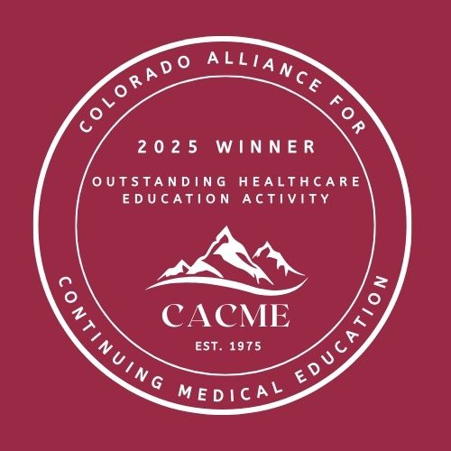
Apex, NC – October 10, 2025 – Iridium Continuing Education, LLC, in partnership with Global Education Group, is proud to announce that its groundbreaking educational program, Rethinking Uncomplicated UTIs: Diagnosis, Management, and Novel and Emerging Treatment Options, has been awarded the Silver Award in the Emerging Tech & Immersive Experience – Healthcare & Pharma category at the 20th Annual w3 Awards presented by the Academy of Interactive and Visual Arts (AIVA).
The w3 Awards honor outstanding digital creativity and innovation across the globe, attracting thousands of entries from leading organizations worldwide. This prestigious recognition marks the second major award for the program, which previously received the 2025 CME Outstanding Healthcare Education Activity award from The Colorado Alliance for Continuing Medical Education (CACME).
Revolutionizing Healthcare Education Through Conversational AI
What sets this award-winning program apart is its innovative use of conversational AI patient simulation technology. The immersive learning experience allows healthcare professionals to engage in realistic, dynamic patient interactions through spoken conversations with AI-powered virtual patients. Learners can conduct patient interviews, analyze symptoms, and develop treatment plans while receiving immediate, personalized feedback on their clinical performance.
The program addresses a critical gap in healthcare provider education by offering comprehensive, evidence-based guidance on the diagnosis and management of uncomplicated urinary tract infections. By combining cutting-edge conversational AI with clinical expertise, the simulation replicates the complexity of real-world patient encounters, enabling healthcare professionals to refine their diagnostic skills and stay current on both established and emerging treatment approaches.
"This recognition from the Academy of Interactive and Visual Arts validates our commitment to delivering exceptional educational experiences that combine clinical rigor with innovative digital engagement," said Melissa Wiles, President, of Iridium Continuing Education, LLC. "Our conversational AI patient simulation represents the future of medical education—providing healthcare professionals with hands-on, interactive learning that truly prepares them for clinical practice. We're honored that our work is making a meaningful difference in how healthcare professionals approach UTI management."

Demonstrated Impact on Clinical Practice
The program has reached more than 1,500 learners to date, with impressive outcomes demonstrating real-world impact:
- 95-98% satisfaction across all program components, with learners praising the interactive format as "engaging," "valuable," and "unique"
- Statistically significant knowledge and competence gains (P<0.05) across all five learning objectives
- 16 percentage point increase in confidence managing uncomplicated UTIs (60% to 76%)
- 91% of learners committed to changing their practice based on program insights
- Nearly 6,000 patients expected to benefit monthly from improved provider knowledge
- The AI platform's personalized feedback helped 74% of learners plan to refine their antibiotic prescribing practices, directly supporting antibiotic stewardship efforts.
The program's success reflects the collaborative efforts of Iridium Continuing Education and Global Education Group, through educational grant support provided by GSK.
About the w3 Awards
The w3 Awards, sanctioned and judged by the Academy of Interactive and Visual Arts, is the premier competition recognizing creative excellence on the web. The Academy is an invitation-only body consisting of top-tier professionals from acclaimed media, interactive, advertising, and marketing firms.
About Iridium Continuing Education, LLC
Iridium Continuing Education, LLC is a leading provider of innovative continuing medical education programs, dedicated to advancing healthcare knowledge and improving patient outcomes through evidence-based educational initiatives and emerging technologies.
About Global Education Group
Global Education Group partners with healthcare organizations to accredit, develop and deliver high-quality educational programs that address critical gaps in medical knowledge and practice.
About GSK
GSK is a global biopharma company with a purpose to unite science, technology, and talent to get ahead of disease together. The company is committed to supporting independent medical educational initiatives that advance healthcare professional knowledge and improve patient care.
For more information about the award-winning program, please contact:
Iridium Continuing Education, LLC
mwiles@iridiumce.com

