FOR IMMEDIATE RELEASE
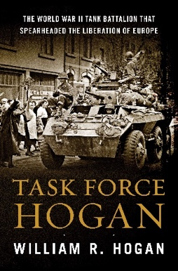


Task Force Hogan wins Gold Medal
The Military Writers Society of America (MWSA) awarded historical nonfiction book Task Force Hogan a Gold medal for the 2025 Book Awards Season. Task Force Hogan is the true story of a WWII tank battalion led by the youngest Lieutenant Colonel in the Army, Samuel Hogan, the author’s father. Local author William R Hogan served 22 years in the United States Army, and used his experiences serving worldwide, as well as his father’s correspondence and after-action reports, to help write the story.
The MWSA review said, “Task Force Hogan by William R. Hogan is a gripping account of the exploits of Task Force Hogan in World War II. From the early days just after the Normandy invasion on D-Day to V-E Day and post-war duties, author Hogan weaves a spell-binding tapestry of action, suspense, heart-felt joy, and heart-wrenching despair of the Third Battalion, Thirty-Third Armored Regiment, 3rd Armored Division as they make their way across France from Normandy on into Germany.”
Military Writers Society of America (MWSA) announced the final winners at the MWSA annual conference and awards banquet in Kansas City on 25 October 2025.
For MWSA’s full book review, please see: https://www.mwsadispatches.com/library/2025/task-force-hogan.
For review copies or interviews, please contact the author at whogan.history@gmail.com or 203-243-0801.

About Task Force Hogan

[Task Force Hogan (Harper Collins, 2023)] tells the story of a WWII tank battalion led by the youngest Lieutenant Colonel in the Army, Samuel Hogan, that fought from Normandy to the Elbe River. The 320-page Narrative nonfiction novel has received writing awards and glowing reviews. It is available via harpercollins.com for distribution. For additional information, please see www.taskforcehogan.com.

