FOR IMMEDIATE RELEASE

Tight Inventory and NYC Migration Drive
Bidding Wars in Westchester Real Estate Market

Westchester County’s Q3 2025 Market Report
Shows County-Wide Price Growth Despite Inventory Pressures

The Zach & Heather Harrison Team Releases Exclusive
‘Bidding War Intensity Chart’ Highlighting the Region’s Hottest Markets

Westchester County, NY (October 28, 2025) – The residential real estate market across Westchester County remained intensely competitive in Q3 2025, as strong buyer demand pushed prices higher despite limited inventory. To spotlight the most competitive local markets, The Zach & Heather Harrison Team at Compass — the #1 residential sales team in Westchester — released a new Bidding War Intensity Chart, ranking towns by the sharpest drops in Days on Market (DOM), a leading indicator of bidding war activity.

According to the team’s exclusive analysis, year-to-date single-family home sales rose 4.7 percent, with total sales volume climbing 10.4% to nearly $5 billion ($4.347B to $4.799B). The county-wide median sale price for single-family homes jumped 6.3 percent to $999,000, while the average price increased 5.4 percent to $1.34 million. Condos and co-ops also saw strong appreciation, with median condo prices up 6 percent and co-op prices rising 9.8 percent year-over-year. Overall, the market continues to tighten — and the new intensity chart confirms where buyer competition is most aggressive.

“It's an incredibly tight market,” said Zach Harrison, co-leader of The Zach & Heather Harrison Team. “The level of demand has led to a surge in bidding wars across nearly every price point. Buyers are coming prepared, and listings priced right are often receiving multiple offers within days.”

Heather Harrison added, “We're seeing a noticeable uptick in buyers coming from New York City, especially with the uncertainty around the upcoming mayoral election. There’s been a sharp increase in families looking to leave the city and settle in the suburbs before year-end. Westchester’s schools, space and stability are drawing strong interest.”

While sales volume and prices have risen, condo sales declined slightly by 3.3 percent, and rental activity dipped by 1.0 percent, suggesting that buyers are aggressively shifting toward ownership amid changing market conditions.

County-Wide Highlights:

- Single-Family Homes:
  - Sales: +4.7%
  - Median Price: $999,000 (+6.3%)
  - Average Price: $1,336,031 (+5.4%)
- Condos:
  - Sales: -3.3%
  - Median Price: $530,000 (+6.0%)
  - Average Price: $667,817 (+7.0%)
- Co-ops:
  - Sales: +8.5%
  - Median Price: $225,000 (+9.8%)
  - Average Price: $263,899 (+7.7%)
- Rentals:
  - Rentals: -1.0%
  - Median Price: $3,500 (+4.9%)

Town-Level Highlights:

Several towns across Westchester stood out for dramatic shifts in pricing and activity:

- Ardsley:
  - Median single-family home price soared 27.2% to $1.1M
  - Sales volume jumped 49.2%
  - Condos saw a 31.6% increase in median price
- Katonah-Lewisboro:
  - Single-family home sales surged 30.3%
  - Average price rose 26.1%, with a 21% jump in median price
- Pelham:
  - Sales climbed 30.2%
  - Median price rose 8.0% to $1.64M
  - Average price grew 12.6%
- Bronxville (decline):
  - Single-family home sales dropped 26.5%
  - Total sales volume fell 24.1%, though prices continued to edge up slightly
- Greenburgh (steep decline):
  - Single-family home sales plummeted 82.1%
  - Condo sales fell 93%, and co-op activity dropped 80%
  - Average days on market in all categories surged

Top Towns with Highest Bidding War Pressure:
- Bronxville: down 29.1%
- Chappaqua: down 22.9%
- Byram Hills: down 17.1%
- Harrison: down 26.2%

The Bidding War Intensity Chart visualizes the towns where buyer demand is strongest—those with the steepest drop in DOM are most likely experiencing multiple-offer scenarios and aggressive competition.

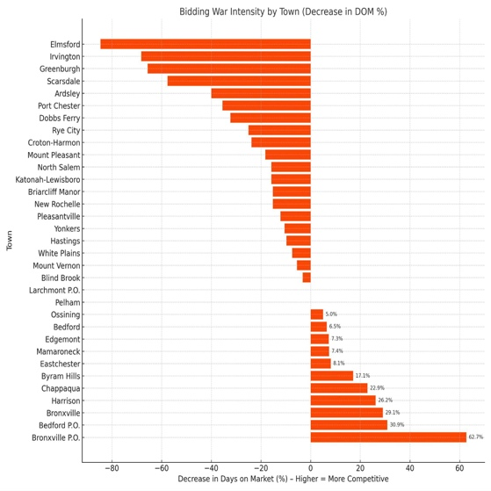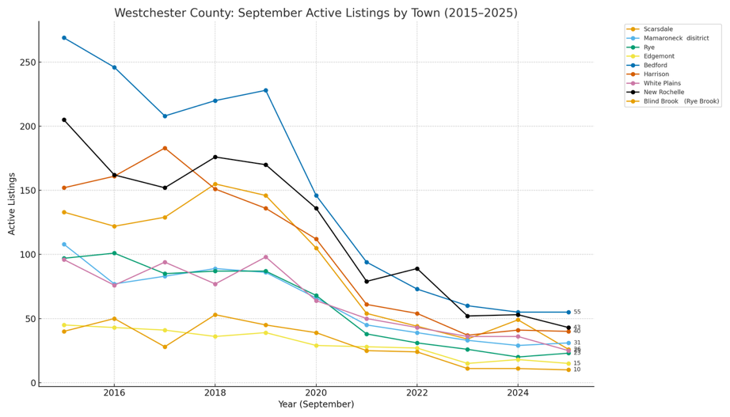

Active listings across Westchester County have dropped dramatically since before the pandemic, underscoring just how tight inventory has become.

According to MLS data, the number of single-family homes on the market in September 2025 totaled roughly 1,700 countywide—down from more than 5,100 in September 2019, representing a stunning 67 percent decline in active listings countywide. Every community has felt the squeeze: on average, towns recorded a 72 percent drop in active listings over that six-year period, illustrating the severe supply constraints driving today’s competitive market conditions.

As the year closes out, The Zach & Heather Harrison Team anticipates continued upward pressure on prices, fueled by limited inventory and a growing exodus of city dwellers looking north.

“As we head into the end of the year, we expect prices to keep climbing,” said Zach Harrison. “There’s simply not enough inventory to meet the demand, and the flow of buyers moving up from the city has only intensified. Every well-priced home is getting multiple offers—it’s an incredibly competitive environment.”

RESOURCES
To view the Compass Q3 2025 Westchester County market report, please visit: https://drive.google.com/file/d/1UWeRRKVz6dRbGRwj2Lr29K24NvWk8RHa/view?usp=sharing

To view or download the Bidding War Intensity Chart and Active Listings by Town Chart, please visit: https://drive.google.com/drive/folders/1aUS-Dh1Q2SqP9jnKLlqT7pbQxm_Ri07U?usp=sharing

To view or download and image of Zach and Heather Harrison, please visit: https://drive.google.com/file/d/1VaFWpIgsfI2v51xDWLSzNBU7YCgUG_jZ/view?usp=sharing

Instagram: @thezhhteam

LinkedIn:
Zach Harrison
Heather Harrison

Media Contact:
Erica Langendorff
Transmitter
516.554.3636
erica@transmitterpr.com
www.transmitterpr.com

