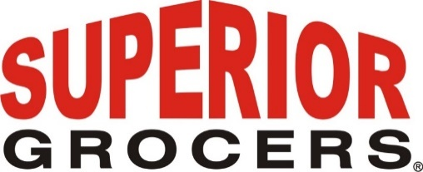

FOR IMMEDIATE RELEASE
Superior Grocers Supported Food Banks Amid Recent SNAP/EBT Uncertainty
Partnership with Los Angeles Regional Food Bank and Second Harvest Food Bank of Orange County helped feed families during temporary benefit disruption
Los Angeles, CA — November 7, 2025— As families across Southern California faced uncertainty earlier this week due to the temporary SNAP/EBT funding disruption, Superior Grocers quickly expanded its community food donation program to ensure families in need continued to have access to essential food items.
Working in partnership with the Los Angeles Regional Food Bank and Second Harvest Food Bank of Orange County, both members of the Feeding America network, Superior Grocers and its supplier partners stepped up to help fill the gap during the disruption and continue to support local families now that SNAP and EBT funding have been fully restored.
This effort included milk donations from Rockview Family Farms, rice, beans, and pasta from Mercado Latino, quality meats and deli products from FUD, and additional contributions of fresh produce from Idaho Potatoes. These items were distributed through local food banks to provide relief to households experiencing food insecurity.
“We know how much families depend on SNAP and EBT benefits and how distressing it was when those benefits were temporarily at risk,” said Richard Wardwell, President and CEO, Superior Grocers. “Even in uncertain times, our focus remains on supporting the communities we serve. We’re proud to have partnered with our local food banks and supplier partners to ensure families could continue putting food on the table.”
“Thank you, Superior Grocers, for your generous donation of milk, bagged potatoes, and assorted dry foods,” said Jeanna Kindle, Chief Product Acquisition Officer for the Los Angeles Regional Food Bank. “These items will make a meaningful difference in the lives of families facing food insecurity across Los Angeles County.”
“We are deeply grateful to Superior Grocers for their generous support of Second Harvest and the Orange County community,” said Claudia Bonilla Keller, CEO, Second Harvest Food Bank of Orange County. “Many families, seniors, and workers across OC are facing real uncertainty about how to put food on the table. This support helps ease that burden and brings hope to those who need it most.”

If you or someone you know is in need of food assistance, please visit Feeding America’s food-bank finder at feedingamerica.org/need-help-find-food to locate free groceries and resources nearby

About Superior Grocers
Founded in 1981, Superior Grocers is one of the largest independently owned supermarket chains in Southern California. With a commitment to Quality, Variety, and Value, Superior Grocers proudly serves diverse communities through its retail stores, employee programs, and philanthropic initiatives. The company actively supports local schools, nonprofits, and food banks through the Superior Foundation and other community partnerships.
For more information, visit www.superiorgrocers.com.

Media Contact:
Dale Nakata
Vice President of Marketing
Superior Grocers
dnakata@superiorgrocers.com

@SUPERIORGROCERS

Visit Our Website
Superiorgrocers.com

