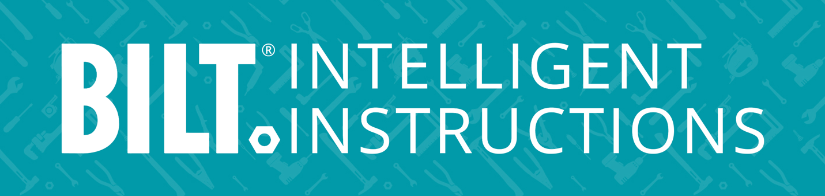
FOR IMMEDIATE RELEASE
BILT Named “Series B & Beyond” Startup of the Year by Venture Dallas
GRAPEVINE, TX – November 18, 2025 – BILT Incorporated, creators of the 3D Intelligent Instructions platform, has been named “Series B & Beyond Startup of the Year” by Venture Dallas, recognizing the company’s continued innovation and growth in the North Texas technology ecosystem.
Projections indicate the region is adding more than 20,000 tech jobs this year with 14,000 of those jobs in the Dallas area alone, leading major metros in STEM wage growth at 33 percent. This growth has attracted significant investment, with more than $1 billion in startup capital projected this year. Companies including Google, Meta, and Salesforce are expanding into the area, thanks to the pro-business climate, growing talent pool, and robust infrastructure.
BILT earned top honors among an impressive group of finalists, including AmplifAI, Cariloop, Koya Medical, Trust & Will, and OneDay. Other categories included seed funding and Series A companies; awards were presented at the Venture Dallas annual conference at the George W. Bush Institute at Southern Methodist University.
“It’s a privilege to be part of this vibrant innovation community,” said BILT Chairman & CEO Nate Henderson. “This recognition underscores our mission to revolutionize guided work and enable the next generation of technicians, installers, mechanics, and even DIYers.”
Judges identified the top six companies nominated in each category. Students from The University of Texas at Dallas produced detailed deal memos on each finalist, followed by a vote from student judges and then foundational investor sponsors. BILT was the unanimous choice for this year’s Series B & Beyond honor.
Venture Dallas, a 501(c)(6) nonprofit and volunteer-led organization, connects startup investors with high-growth regional companies and fosters collaboration across the venture capital and entrepreneurial ecosystems.
###
About BILT:
Millions of users follow 3D Intelligent Instructions for thousands of products from hundreds of brands. BILT revolutionizes professional training, operational enablement, and the user experience for assembly, installation, maintenance, and repair. The award-winning platform delivers turnkey interactive instructions on iOS, Android, Windows, and immersive spatial computing instructions on Apple Vision Pro. BILT is accessible, sustainable, and efficient.

Contact:
Juliette Qureshi
VP, PR & Media Comms
Juliette@BILTcorp.com
703-554-3020

