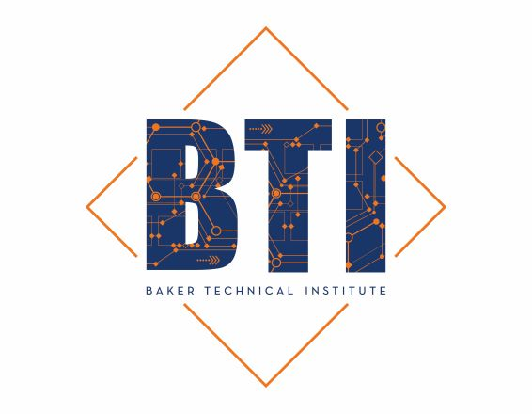
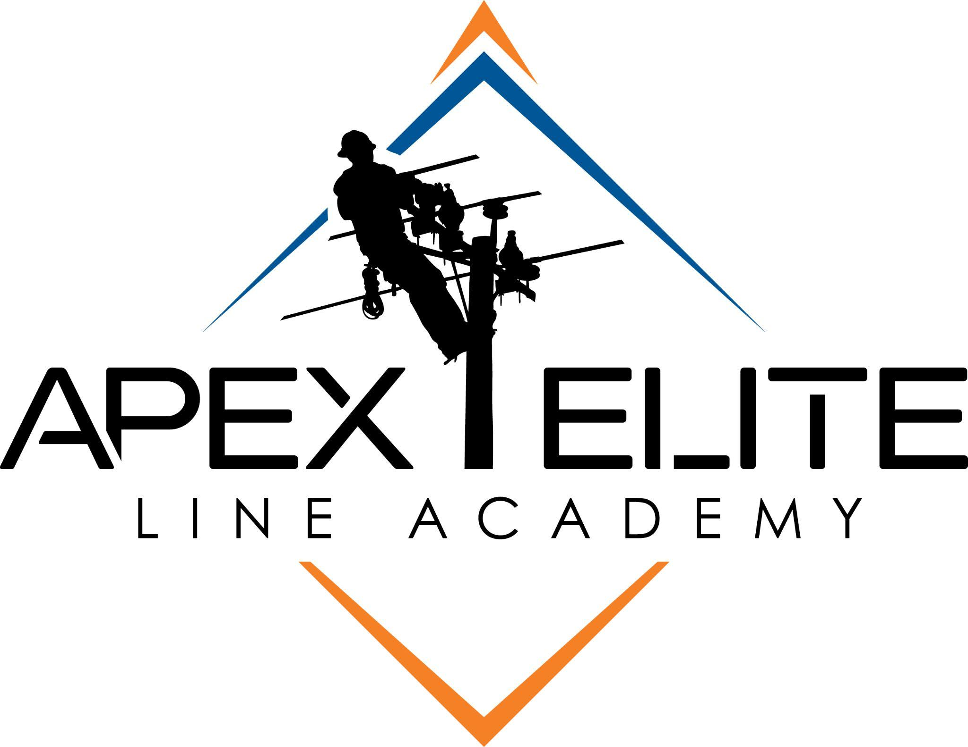

FOR IMMEDIATE RELEASE
Media Contact:
Baker Technical Institute
Doug Dalton
📞 541.524.2651
🌐 bakerti.org

Baker Technical Institute Announces Launch of APEX Elite Line Academy

- A New Standard in Lineworker Training -
Baker City, Oregon - November 20th, 2025 - Baker Technical Institute (BTI), a leading nonprofit technical college known for its hands-on workforce and technical training programs, is proud to announce the launch of APEX Elite Line Academy, a premier lineworker training school located in Baker City, Oregon.
The APEX Elite Line Academy represents the culmination of years of planning and collaboration between BTI and Oregon Trail Electric Cooperative (OTEC), a partnership built upon the common goal of creating economic resiliency in the rural communities they operate in, along with being committed to strengthening the future of the power and utility industry while creating new opportunities for students across the region. “Oregon Trail Electric Cooperative is proud to partner with BTI on this initiative,” said Les Penning, CEO of OTEC, “Together, we’re investing in people, communities, and the infrastructure that keeps rural Oregon strong.”
The state-of-the-art training facility, currently under construction, represents a significant advancement in workforce development for rural communities throughout the Pacific Northwest. With an expected completion in spring 2026, the first cohort of students is set to commence training in June 2026. The school will then offer three separate 14-week sessions per year. This initiative builds upon BTI’s growing portfolio of successful programs, including Construction, Heavy Equipment Operation, Welding, CDL Truck Driving, Safety Training, Healthcare, and more.
“The launch of APEX Elite Line Academy is about more than just training lineworkers, it’s about developing leaders of character who are prepared to power our communities,” said Doug Dalton, President of Baker Technical Institute. “We’re creating an environment that blends technical excellence with leadership, teamwork, and integrity - skills that are essential both on and off the job site. Our goal is to set the highest standard of training that results in the most sought-after graduates in the industry.”

Training the Next Generation of Lineworkers
Electrical lineworkers play a critical role in maintaining and expanding our nation’s power grid. As retirements increase and infrastructure demands grow, the need for skilled lineworkers has reached historic levels across Oregon, the Pacific Northwest, and the western United States.
APEX Elite Line Academy is designed to meet that challenge head-on. The program will emphasize:
- Small Cohorts (40 or fewer students) to ensure quality instruction and individualized mentorship.
- Comprehensive Curriculum covering critical topics from electrical theory, pole climbing, line construction, heavy equipment operation, transformer work and rigging, to OSHA safety training, leadership development, essential career skills, and more.
- Extensive Hands-On Learning students will train in a real-world environment using quality industry equipment in a realistic training yard and modern instructional facility. Learning by doing the work with your team will be a priority at APEX.
- Instruction by Experienced Industry Professionals with decades of experience in linework, safety, and utility operations.
Graduates will be equipped not only with the technical expertise required for linework, but also with the leadership, character, and resilience needed to succeed in one of America’s most essential and respected careers.

The APEX Lifestyle - Where Training Meets Adventure
Located in the scenic heart of Baker City, Oregon, APEX students will live and learn in a place that embodies the outdoor lifestyle many linemen cherish. Surrounded by mountains, rivers, and endless opportunities for recreation, the APEX experience is about more than just education - it’s about building a community of hardworking, service-minded individuals who thrive both on the job and in life.

Supporting Rural Workforce Growth
The creation of APEX Elite Line Academy marks the latest initiative by Baker Technical Institute to support regional economic development and rural workforce stability. By providing access to world-class technical training, BTI continues to empower students and strengthen local industries through skill-based education and community partnerships.
About OTEC
Oregon Trail Electric Cooperative (OTEC) is one of Oregon's largest distribution cooperatives. Headquartered in Baker City, Oregon, with district offices in La Grande, John Day, and Burns, OTEC serves approximately 31,000 meters in Baker, Grant, Harney, and Union counties with a network of overhead and underground lines approximately 3,000 miles long. OTEC's distribution system represents an investment of more than $204 million.
About BTI
Baker Technical Institute (BTI) is a leading provider of Career Technical Education programs focused on developing the next generation of skilled workers, technology innovators, entrepreneurs, and community leaders. Headquartered in Baker City, Oregon, BTI offers cutting-edge education and training, leading to certification in high-wage, high-demand careers, such as construction, line work, heavy equipment operation, truck driving, welding, computer sciences, agricultural sciences, natural resources/environmental sciences, engineering, health services, and manufacturing. For more information, go to bakerti.org

More Information
Visit apexlineacademy.com or contact BTI at 541.524.2651 for media inquiries, partnership opportunities, or student admissions information.

