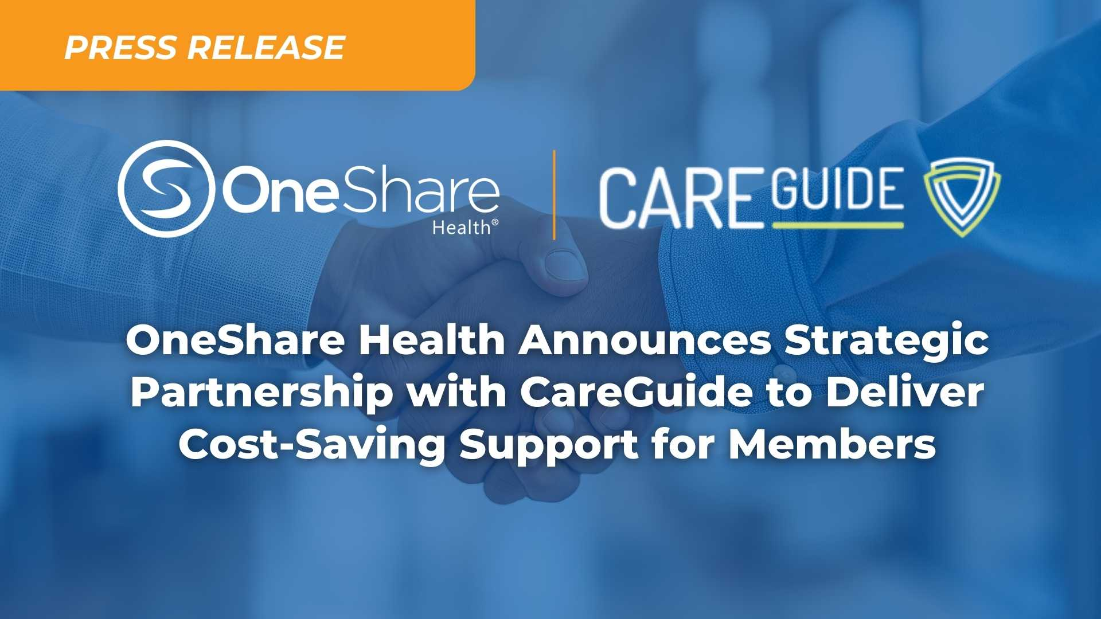
FOR IMMEDIATE RELEASE January 16, 2025
OneShare Health Announces Strategic Partnership with CareGuide to Deliver Cost-Saving Support for Members
Irving, TX – OneShare Health, a nationally recognized Health Care Sharing Ministry (HCSM), is proud to announce a strategic partnership with CareGuide, a premier medical cost advocacy company dedicated to negotiating fair and cost-effective pricing on behalf of OneShare Health and its Members. This partnership strengthens OneShare Health’s commitment to ensuring Members receive access to affordable health care options by offering individualized billing support, and expert negotiation advocacy supported through CareGuide.
As the cost of health care continues to rise, navigating medical bills and understanding charges can be an overwhelming experience for individuals and families. Through this collaboration, OneShare Health Members receive direct access to CareGuide’s team of seasoned patient advocates, who work directly with providers and health care facilities to negotiate and reduce out-of-pocket costs—often by significant margins.
“We are pleased to partner with CareGuide to support the careful and responsible stewardship of our Members’ sharing dollars,” said Jen Slutzker, CEO of OneShare Health. “This partnership has already yielded extraordinary results for OneShare Health Members, as CareGuide has provided support for $5,797,316.23 worth of additional health care savings in 2025.”
The OneShare Health and CareGuide partnership is active and available to all eligible Members. This added layer of advocacy further empowers individuals to focus on what matters most, healing and wellness, while CareGuide takes the lead in securing the most equitable financial outcomes. This collaboration directly supports OneShare Health’s mission of compassionate, community-driven care by providing Members with the tools and support needed to manage additional medical costs with confidence.
CareGuide helps Members lower or even eliminate big medical bills, find affordable doctors and prescriptions, and get support with understanding and navigating the health care system. For more information on this partnership or to learn how to access CareGuide’s services, Members are encouraged to visit OneShareHealth.com or contact Member Support directly at MemberSupport@OneShareHealth.com.
##
About OneShare Health
OneShare Health is an ACA-exempt, Christian Health Care Sharing Ministry based in Irving, Texas, dedicated to helping individuals and families access quality, affordable health care. As a nonprofit organization, OneShare Health facilitates the sharing of medical expenses among its members, providing an innovative alternative to traditional health insurance that aligns with Christian principles. With a commitment to transparency, integrity, and compassion, OneShare Health is transforming the health care experience for its members by offering comprehensive health care solutions that prioritize affordability, accessibility, and community.

Media Contact:
For media inquiries or more information about OneShare Health, please contact:
Marketing@OneShareHealth.com

