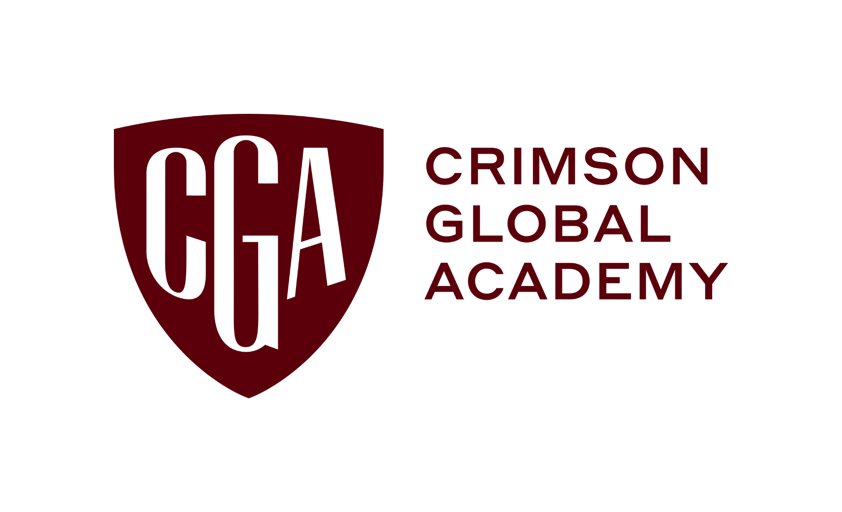
FOR IMMEDIATE RELEASE

Crimson Global Academy Honors Nashville International Chopin Piano Competition 2025 Winners
As the winner of the Young Musician II category, 11-year-old pianist Wilson Liu earned a 50% tuition scholarship to Crimson Global Academy
[NASHVILLE, Tenn.] January 22, 2026 — The Nashville International Chopin Piano Competition (NICPC) has announced the winners of its 2025 competition, held at Lipscomb University from December 14-19. As the winner in the Young Musician II competition category, 11-year-old pianist Wilson Liu earned $500 and a 50% tuition scholarship to Crimson Global Academy (CGA). The jury also awarded Liu a special Junior Alexei Sultanov Prize for exceptional artistry and musical promise.
This year’s competition brought together exceptional young pianists from around the world in the heart of “Music City,” continuing NICPC’s mission to elevate emerging classical artists and celebrate the legacy of Frédéric Chopin.
The 2025 competition featured 40 finalists ages 6-28, representing 15 countries. Participants performed a range of Chopin works in front of an international jury of distinguished pianists and educators. A complete list of winners is available here. The overall first prize was awarded to Guangbin Wang, a blind pianist from China, who said, “Music allows me to see the world in my own way, beyond limits and beyond boundaries. On this stage, I felt not judged by what I cannot see, but heard for what I have to say.”
This was the first year NICPC partnered with Lipscomb University and CGA. “Partnering with Crimson Global Academy allows us to provide our young pianists with a unique opportunity to balance music and educational excellence, ensuring they thrive on stage and in the classroom,” said Graciella Kowalczyk, president and artistic director of NICPC.
Brittanie Bates, principal of the US Diploma Pathway at CGA, concluded, “CGA heartily congratulates Wilson Liu and all the NICPC winners. We look forward to supporting more young artists through our flexible, globally accessible learning model, which empowers students to dedicate more time to refining their artistry while pursuing a rigorous education.”
About Crimson Global Academy
Crimson Global Academy (CGA) is an internationally accredited online private school delivering live, real-time classes to students aged 8–18 across more than 70 countries. Established in 2019, CGA offers globally recognized qualifications including the International GCSEs and A Levels (Pearson Edexcel and Cambridge), Advanced Placement (AP), and the US High School Diploma. The school is also accredited by the Western Association of Schools and Colleges (WASC).
CGA’s 250+ experienced teachers provide more than 2,000 students personalized attention and a flexible 24/7 timetable across multiple time zones. In classes of 10–12, students are placed by ability and maturity rather than age, enabling accelerated learning. As part of the Crimson Education network, CGA benefits from world-class resources and connections that have helped thousands of students secure admission to the world’s most competitive universities. Learn more at CrimsonGlobalAcademy.school/us.
About the Nashville International Chopin Piano Competition
The Nashville International Chopin Piano Competition is dedicated to supporting the next generation of world-class pianists while honoring the enduring legacy of Frédéric Chopin. The competition offers young musicians an opportunity to perform on an international stage, receive expert jury feedback, and advance their careers through recognition, performance opportunities, and prize support.
Media Contact:
Hollie Boodram
Hboodram@hawkemedia.com

