Malawian Physician Dr. Agnes Moses Wins $500,000 Gerson L’Chaim Prize to Expand Surgical Care and Strengthen Healthcare Systems at Partners in Hope Hospital
FOR IMMEDIATE RELEASE
NAIROBI, Kenya — January 2026 —
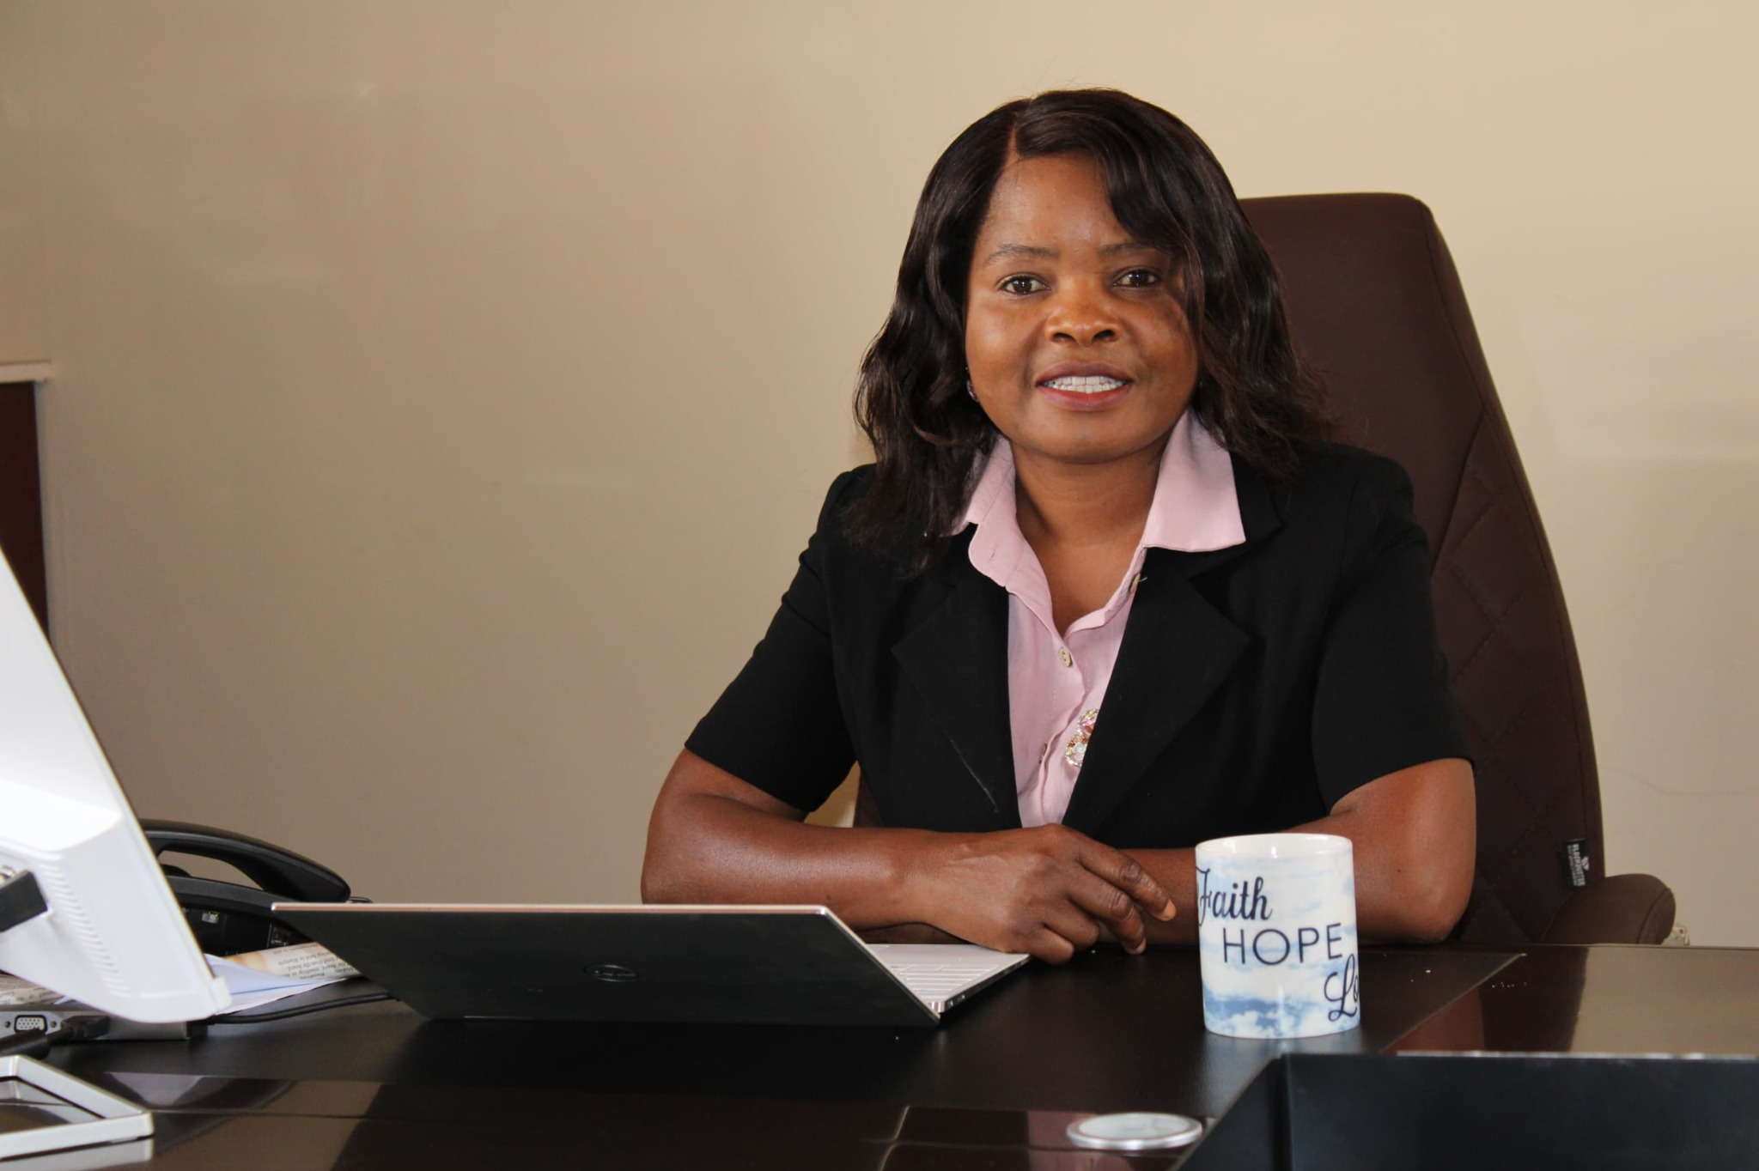
African Mission Healthcare (AMH) today announced that Dr. Agnes Moses, Executive Director of Partners in Hope (PIH) in Malawi, is the recipient of the 2025 Gerson L’Chaim Prize for Outstanding Christian Medical Missionary Service—a $500,000 award described by AMH as the world’s largest annual award for direct clinical care. The prize is granted to the laureate’s institution to support high-impact, life-saving health programs.
Dr. Jon Fielder, Co-Founder and CEO of African Mission Healthcare, said, “The $500,000 investment at Partners in Hope will recruit an additional surgeon and purchase laparoscopic equipment, expanding access to much-needed surgical services. The award will also help PIH continue its commitment to free HIV care for the poor, supporting continuity of care for vulnerable patients while strengthening long-term local capacity.”
A Proven Model of Care Delivery in Malawi
Founded in 2004 in response to Malawi’s HIV epidemic, Partners in Hope has grown through a close partnership with the Malawi Ministry of Health into one of the country’s most effective care delivery systems. As of early 2025, PIH was caring for more than 220,000 HIV patients across nine districts, providing 20% of Malawi’s viral load laboratory services, and mentoring 130 clinics and hospitals.
AMH has worked closely with Partners in Hope for more than 16 years and has seen its growth from a missionary-led HIV program into a comprehensive hospital serving some of the most vulnerable people in Malawi. At a time when global health programs face funding transitions and increased pressure to demonstrate efficiency and sustainability, this investment helps ensure continuity of care while strengthening local capacity.
“Dr. Agnes Moses embodies the very heart of the L’Chaim Prize,” said Dr. Fielder. “Her faith, humility, and unwavering dedication to the people of Malawi have resulted in measurable improvements in healthcare delivery, workforce development, and institutional excellence.”
Strengthening Healthcare Systems Beyond HIV
While Partners in Hope remains a national leader in HIV care, the hospital’s mission extends well beyond HIV services. PIH provides general medical and surgical care, intensive care, laboratory and radiology services, renal dialysis, and emergency care to a large and diverse catchment area in central Malawi—one of the poorest countries in the world, with more than half its citizens living below the international poverty line of $2 per day.
The Gerson L’Chaim Prize is designed to serve as a catalyst for this broader vision. Building on the surgical expansion supported by the prize, Partners in Hope is poised to further strengthen its healthcare system by adding additional healthcare workers, investing in essential medical equipment, and expanding clinical outreach to surrounding communities. These next-phase investments are expected to require an additional $700,000 and will significantly increase the hospital’s ability to care for patients with complex and urgent medical needs.
African Mission Healthcare will launch a campaign with Dr. Moses this spring to help raise these funds, inviting donors and partners to join in expanding access to quality, compassionate care for those in greatest need across Malawi.
“I am deeply grateful to African Mission Healthcare and the L’Chaim Committee for this recognition,” said Dr. Moses. “This award affirms the calling of our staff and partners to provide excellent, compassionate care while strengthening Malawi’s healthcare system for generations to come.”
About the Gerson L’Chaim Prize and L’Chaim Initiative
L’Chaim is a Hebrew phrase meaning “to life.” African Mission Healthcare’s L’Chaim Initiative was established by AMH co-founder Mark Gerson and board member Rabbi Erica Gerson and includes the annual L’Chaim Prize, the Mission Hospital Teaching Network, and the L’Chaim Scholars program. The L’Chaim Prize is awarded annually to a Christian medical missionary whose work reflects extraordinary commitment to saving lives and strengthening healthcare in under-resourced communities across Africa. https://africanmissionhealthcare.org/program/lchaim-initiative/

Media Contact:
Dené Marcello
Director of Development
African Mission Healthcare
Direct: 614-259-7220
Dene.Marcello@AfricanMissionHealthcare.org
Info@AfricanMissionHealthcare.org
Media Kit Link

