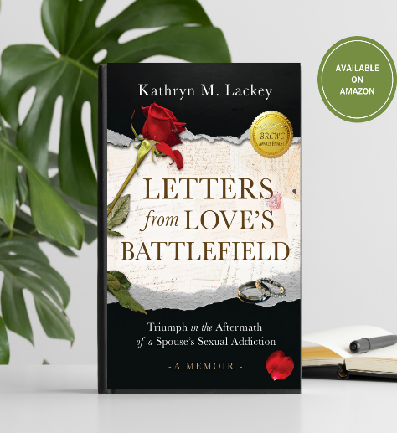
PRESS RELEASE

**FOR IMMEDIATE RELEASE**

Contact:
Kathryn Lackey, Author
Kathryn.m.lackey@gmail.com
214-288-7873
kathrynmlackey.com

Award-Winning Author Brings Voice to Global Threat
Impacting Marriages and Families

Dallas TX, April 3, 2026 — Foundations award winning author, Kathryn M. Lackey, was recently honored to receive a CIPA literary award for her deeply personal and faith-driven memoir, Letters from Love’s Battlefield: Triumph in the Aftermath of a Spouse’s Sexual Addiction. This award was announced at the annual Blue Lake Christian Writer’s Conference in Andalusia, AL hosted by Director, Susan Neal, of the Christian Indy Publishers Association (CIPA.) More than a literary achievement, this recognition awards her personal non-fiction rendering through a partner’s hidden addiction and sex crimes, unveiling the silent threat to marriages and families while giving a voice to its true victims, the women impacted by its devastations in cultures across the globe.

Written from the rawness of personal experience, Letters from Love’s Battlefield journals a rare glimpse into the frontlines of addiction’s emotional battlefield. Lackey shares, “Wives and partners of the addict are often blindsided and shamed while thrust into the trauma of an unforeseen battle, ill-equipped for the maze of destruction that lies ahead. Upon discovery, their lives suddenly evaporate into a twilight zone as they desperately try to distinguish what was real, and what was not.”

As luring online accessibility and societal norms continue to redefine true love and intimacy, global statistics reference a sex industry and “Porndemic” explosion with degenerative impact to families in all cultures. Blending faith, personal reflection, and practical encouragement, the author guides readers through the painful realities of progressive online sexual addiction and the silent threat it poses to today’s marriages and families. Her story compassionately identifies with women isolated, shamed, and traumatized by their partner’s addiction, and through her memoir, seeks to change the narrative at a time when conversations around marriage and sexuality, online influences, and mental health are critical in our digital evolution.

Letters From Love’s Battlefield: Triumph in the Aftermath of a Spouse’s Sexual Addiction, by Kathryn M. Lackey is available for purchase on Amazon.
(Paperback ISBN 978-1-960814-07-4, $14.99; Kindle Version ISBN 978-1-960814-08-1 $9.99, 128 pages)
Publisher: Brookstone Publishing Group
Additional author information and media coverage can be found at kathrynmlackey.com.

About the Author
Kathryn Lackey is the Founder and Principal Designer of Heart of the Home Styling & Designs, a Dallas-based interior design, renovation, and home staging studio. She continues to find beauty through design therapy, and advocates women navigating divorce and relational sexual addiction trauma through church support groups, guest podcasting, and future writings.

###

