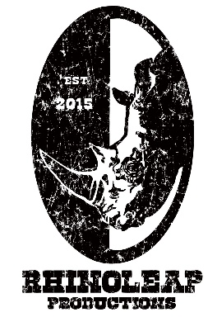
RhinoLeap Presents The Complete Works of William Shakespeare (Abridged)

Asheboro, NC – RhinoLeap Productions announces its second production of its 2026 Season will be The Complete Works of William Shakespeare (Abridged). Complete Works is London’s longest running comedy, and since coming to America it has been a huge hit across the country for decades. The original three performers are also credited as the writers (Adam Long, Daniel Singer & Jess Winfield) though they encourage every production to make the piece their own by continually updating modern references and humor. RhinoLeap has cast three actors with Broadway and Cirque du Soleil experience to meet the physical challenges of the play while adding an additional twist: the cast performs the entire piece on a tennis court in Asheboro’s Memorial Park.

Complete Works will be directed by Jeremy Skidmore who has helmed over 80 productions all over the world. The cast features Alex Bodine who is stage combat specialist and graduate of the University of North Carolina School of the Arts, Allen Tedder who graduated from Juilliard and has spent over two years on Broadway, and Patrick Osteen who toured the country in the Broadway National Tour of War Horse and then toured the world in Cirque du Soliel’s Toruk. Patrick is now the Artistic Director of RhinoLeap, which he also co-founded with his father, Dr. Thomas Osteen.

About the Play:

90 minutes. 36 plays. 3 actors. 1 tennis court?

Three fearless performers from Broadway and Cirque du Soleil attempt the impossible: to bring all of Shakespeare’s plays to life in a single performance. Blending comedy, improvisation, and physical storytelling, this high-energy production delights Shakespeare fans and curious newcomers alike.

Performance Location:
Championship Tennis Court @ Memorial Park
898 S Church St + Asheboro, NC

Tickets:

Tickets are available at rhinoleap.com or in-person at the Brightside Gallery located at 170 Worth Street, Asheboro, NC.

Tickets to ALL RhinoLeap productions are free for ALL teenagers living in Randolph County. Just show up to ANY performance 30 minutes before showtime to get your free ticket on a first come, first served basis.



About RhinoLeap: RhinoLeap's mission is to demonstrate the power of the arts to transform rural communities. We reflect those communities with the productions we present and strike a balance between asking meaningful questions and our desire to entertain. We create education programs anchored in truth that encompass all ethnic, religious, and gender identities. RhinoLeap Productions was founded in 2015 and become a non-profit in 2017. Since then, we have produced 40 productions and have performed and/or taught in 17 counties across North Carolina. Our creations include live theater, dance, and music as well as a weekly radio show called CRASH RADIO broadcast on WFDD 88.5FM.

