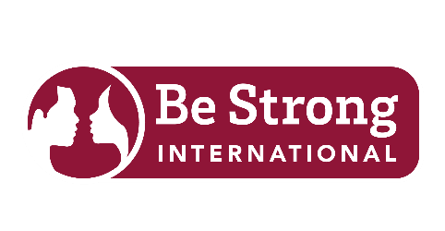

Media Contact:
Monika Sanchez
Be Strong International
press@bestrongintl.org

FOR IMMEDIATE RELEASE
Greener Roofing & Solar Donates $30,000 Roof to Be Strong International, Expanding Impact for 16,000 Families
Local leaders, residents, and partners gather to mark milestone investment strengthening safe spaces for families
PALMETTO BAY, FL – April 13, 2026 – Be Strong International (BSI) welcomed community leaders, partners, and supporters on April 10 to celebrate a $30,000 roof donation from Greener Roofing & Solar, a critical investment that strengthens the organization’s ability to serve more than 16,000 families annually across South Florida. The newly completed roof at BSI’s Palmetto Bay headquarters ensures a safe, stable environment for delivering life-changing relationship and youth development programs.
The celebration brought together local officials, business leaders, and community advocates in a shared commitment to advancing strong, healthy communities. By addressing a vital infrastructure need, the roof installation allows Be Strong International to focus resources on expanding its Heart Skills® programs, which equip youth and families with tools for healthy decision-making, communication, and long-term relationship success. The event also provided an opportunity for attendees to engage directly with the organization’s mission and witness the power of community partnership.
Village of Palmetto Bay Mayor Karyn Cunningham recognized both the organization’s impact and the significance of the contribution. “Be Strong International continues to make a measurable difference in the lives of families throughout our village,” she said. “This partnership shows how local businesses can play a direct role in strengthening communities.” During the ceremony, Mayor Cunningham presented Maycol Delgado, Founder and President of Greener Roofing & Solar, with an official proclamation honoring his leadership and generosity.
“This investment allows us to continue providing consistent, high-quality programming in a space that reflects the value we place on the people we serve,” said Michelle Shirley, CEO and Chief Heart Officer of Be Strong International. “It strengthens our capacity to reach more individuals and families with the skills they need to build healthier, more stable lives.” Delgado added, “This project is about more than a roof. It is about creating a foundation that supports opportunity, stability, and growth for thousands of families across South Florida.”
The event concluded with a renewed sense of collaboration and forward momentum. The roof donation not only resolves a critical facility need but also positions Be Strong International to expand its reach and deepen its impact throughout Miami-Dade County. To learn more about how you can support Be Strong International, visit www.BeStrongIntl.org.
--
About Be Strong International
Founded in 1992 by retired Miami-Dade County Public Schools educator Mrs. Althea McMillan, Be Strong International has spent over 30 years empowering communities in South Florida with practical relationship skills and tools needed to avoid cycles of generational trauma. Through its signature Heart Skills® framework, youth, parents, couples and families learn to experience the joy of healthy relationships and meaningful connections. Since inception, BSI has served over 250,000 youth and families combined and has been recognized as one of the Best Places to Work by the South Florida Business Journal.
About Greener Roofing & Solar
Greener Roofing & Solar is a family-owned company based in Palmetto Bay and a trusted leader in the South Florida community. Rooted in integrity and quality, the company provides roofing and solar solutions designed to protect homes, enhance energy efficiency, and provide homeowners with long-lasting peace of mind. Founded by Maycol Delgado, Greener Roofing & Solar is dedicated to both outstanding craftsmanship and meaningful local impact. This commitment is personal; having grown up in a lower-income environment, Maycol understands the importance of providing resources and support to those in need. This perspective continues to drive the company’s mission today.

