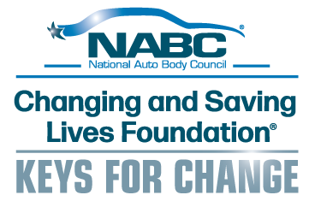
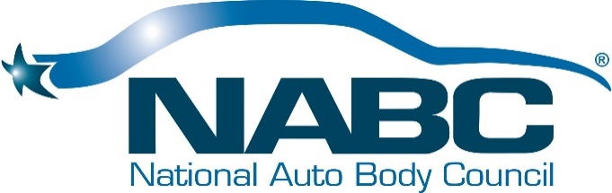

National Auto Body Council® Announces Changing and Saving Lives Foundation®
Keys for Change Program to Drive Funding for Critical Community Programs

PORT CHARLOTTE, FL (March 2, 2026) –- The National Auto Body Council® is announcing a new program to allow automotive companies and consumers alike to help provide donations for the Changing and Saving Lives Foundation® to support the life-changing efforts of the NABC Recycled Rides® program and the life-saving initiatives of the NABC First Responder Emergency Extrication (F.R.E.E.™) program. The Changing and Saving Lives Foundation® Keys for Change program offers the opportunity for those with unwanted vehicles to donate them in an easy, efficient and tax-exempt process, all while helping a good cause.

The Changing and Saving Lives Foundation® Keys for Change program is a way for consumers, car dealers, automotive recyclers and collision repair shops to donate unwanted vehicles, from which proceeds will fund NABC® programs like NABC Recycled Rides® and NABC F.R.E.E.™. These donated vehicles are not typically recycled and refurbished for gifting, but sold for salvage with the proceeds going to fund key programs that serve veterans, military members, families in need and first responders. As demand for the programs offered by the Changing and Saving Lives Foundation® increases, so does the funding need.
If you would like to support the efforts of the National Auto Body Council and help local community members in need, visit https://www.changingandsavinglivesfoundation.org/ .

The process to donate a vehicle – from an unwanted car or truck, to an RV, boat or motorcycle – is easy. By submitting the donation request online or by calling 888.350.KEYS, donors can arrange for the free pickup of their vehicle, coordinate their donation and receive their donation receipt.

“The National Auto Body Council® is one of the most trusted charities in the automotive industry, gifting thousands of vehicles over the years to those in need and providing live-saving training to first responders,” said Tom Wolf, chairman of the board of the National Auto Body Council. “Through our Changing and Saving Lives Foundation® Keys for Change program, we are extending that trust to provide those with unwanted vehicles an easy and efficient way to dispose of their vehicles and help a good cause at the same time. We provide unparalleled transparency in our process, and all proceeds benefit the people and communities we serve.”

The Changing and Saving Lives Foundation® Keys for Change program is available nationwide. Visit here for more information and to donate a vehicle.

ABOUT THE NATIONAL AUTO BODY COUNCIL®

The National Auto Body Council® is the premier organization of collision industry partners dedicated to strategic networking opportunities that positively change lives in the communities we serve. The collaborative membership of the National Auto Body Council® has gifted more than 3,750 vehicles valued at more than $67 million and provided extrication opportunities for some 7,000 First Responders in communities around the country through NABC Recycled Rides® and NABC First Responder Emergency Extrication (F.R.E.E.™).

The NABC Changing and Saving Lives Foundation, a 501c3 organization, is committed to the goal of driving change for veterans, military members, first responders and families in need, while harnessing the power of the collective membership of the collision repair industry to positively impact communities where we live and work. As demand for NABC® programs like NABC Recycled Rides® and NABC F.R.E.E.™ grows, so do the needs for resources to manage these important programs. Being able to pursue grants, gifts and donations allows NABC to expand these programs to serve those in need and help communities where we live and work. The Changing and Saving Lives Foundation Keys for Change program also helps drive funding for key programs. The easy, efficient donation process allows vehicle owners to turn their unwanted vehicles into life-changing support. All vehicle donations fund critical programs that provide support and assistance for families in need, military members, veterans and first responders.
For more information, visit http://www.nationalautobodycouncil.org/ .

###

