AMCI Launches New IO-Link Line to Bring Intelligence Directly to Motion

Terryville, CT – October 1, 2026

Advanced Micro Controls Inc. (AMCI), a leading provider of industrial automation, motion control, and position sensing solutions, today announced the launch of its new IO-Link integrated motor line, combining motor, drive, and intelligent connectivity in a compact, streamlined solution.
Designed for modern machine builders, AMCI’s new IO-Link motors bring communication and diagnostics directly to the point of motion. By integrating drive functionality with the motor and utilizing IO-Link connectivity, the new product family helps simplify machine architecture while giving control systems greater access to device information.
Smarter Motion. Simpler Machines.
Traditional motion architectures can require separate motors, drives, feedback devices, and extensive wiring. AMCI’s integrated approach combines key motion-control functionality into a single device, reducing components and simplifying installation.
With IO-Link connectivity, the motor becomes more than an actuator. It becomes an intelligent device within the automation system, providing access to configuration, identification, diagnostics, and operating data.
Key benefits include:
- Integrated motor and drive functionality for a more streamlined machine design
- IO-Link connectivity for standardized device communication
- Reduced wiring and component count
- Simplified commissioning and configuration
- Device identification and parameter management
- Diagnostic information for faster troubleshooting
- Easy device replacement with parameter restoration
- Greater visibility into machine operation
- Compact design for space-constrained applications
Turning Motors into Intelligent Automation Devices
IO-Link enables manufacturers to connect field devices directly to the control architecture while maintaining access to valuable device-level information.
For machine builders, this can simplify commissioning and provide greater visibility into equipment performance. For maintenance teams, device diagnostics and identification can help reduce troubleshooting time and support faster service. For OEMs, standardized connectivity can help create more consistent machine architectures across applications.
AMCI’s IO-Link motors are designed to take advantage of these capabilities while maintaining the company's focus on practical, reliable industrial automation.
Built for the Next Generation of Automation
The new IO-Link motor line expands AMCI’s motion-control portfolio and supports the industry's movement toward more connected, data-driven machines.
Applications include:
- Packaging machinery
- Material handling
- Assembly equipment
- Conveyors
- Robotics and automation
- Food and beverage machinery
- Printing and converting
- Machine tools
- OEM equipment
- General industrial automation
The product family includes NEMA 17, NEMA 23, and NEMA 34 integrated motors, providing a range of options to meet diverse motion requirements. The portfolio also includes both DC and AC stepper drives and controllers, giving machine builders the flexibility to select the right solution for their application while benefiting from simplified wiring, streamlined commissioning, built-in diagnostics, and IO-Link connectivity.
Extending AMCI’s Integrated Motion Platform
AMCI has decades of experience developing motion control and position-sensing solutions for industrial automation. The new IO-Link motor line builds on that experience by bringing motor intelligence and industrial connectivity closer to the application. The result is a motion solution designed around a simple principle: The smarter the motor, the simpler the machine can be.
Additional configurations and products will be introduced as the AMCI IO-Link platform continues to expand.
For more information about AMCI’s IO-Link integrated motor line, visit AMCI : Advanced Micro Controls Inc :: IO-Link Motion Control Solutions or email applications@amci.com.
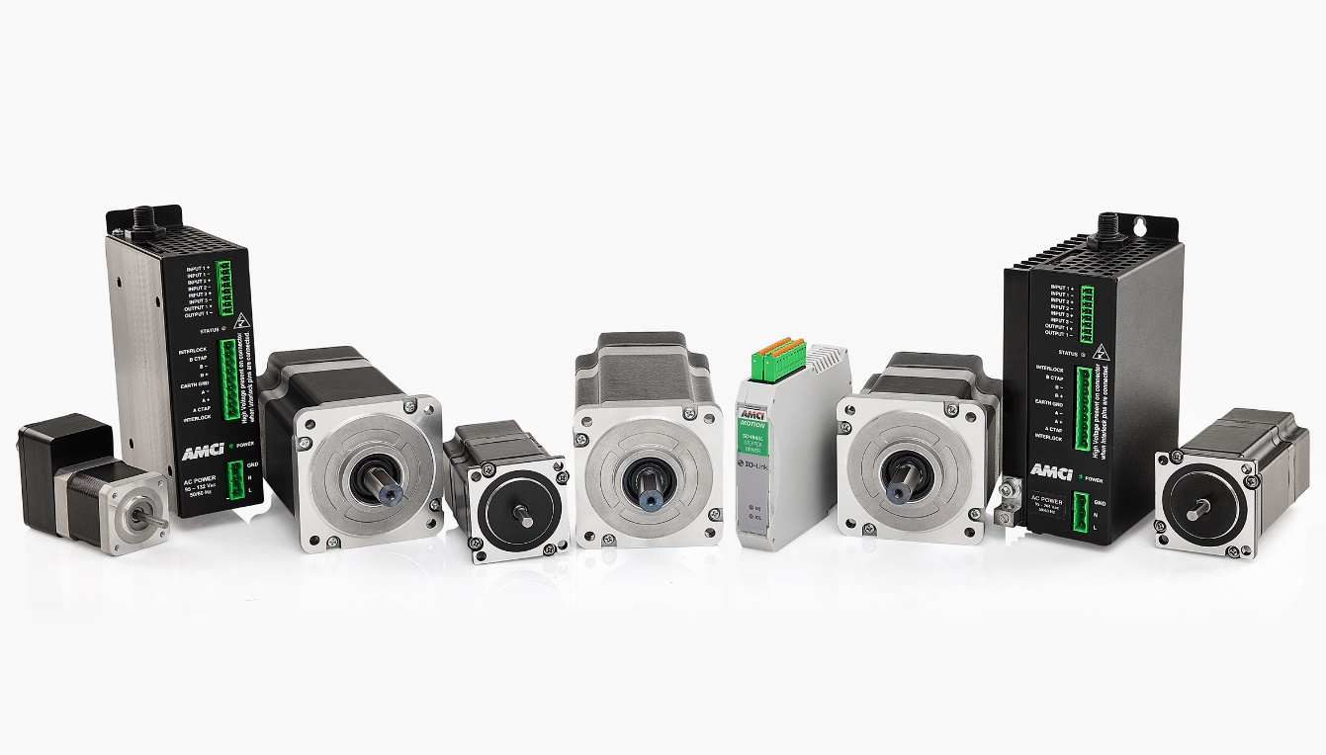

About AMCI
Advanced Micro Controls Inc. (AMCI) is a family-owned manufacturer specializing in industrial automation, motion control, position sensing, and networking solutions. AMCI develops products that help machine builders and manufacturers solve challenging automation applications with reliable, innovative technology.
Founded in Connecticut, AMCI combines decades of automation experience with a focus on practical solutions for today's increasingly connected machines.
Advanced Micro Controls Inc.
20 Gear Drive
Plymouth Industrial Park
Terryville, CT 06786 USA
Telephone: (860)-585-1254
Facsimile: (860) 584-1973
http://www.amci.com

