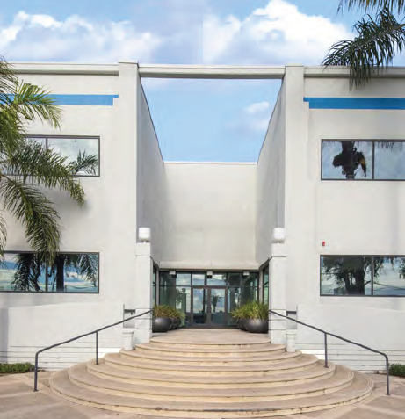


A4 Expands Southern California Headquarters to Support Growth
New Vernon Facility Increases Inventory and Development Capacity

LOS ANGELES, CA — October 21, 2026 — A4, a family-owned manufacturer of premium sportswear, today announced the opening of its new corporate headquarters and West Coast Distribution Center in Vernon, California. The move nearly doubles A4's capacity in Los Angeles and is designed to support the company's growth.
Driven by strong demand across the team, promotional products and corporate apparel markets, A4 continues to expand both its product assortment and inventory investment. The additional warehouse capacity allows the company to stock more styles with deeper inventory in Southern California, giving West Coast customers faster access to the products they need.
"Our business has grown consistently over the past decade because our customers continue to place their trust in A4," said Mark Mertens, Owner of A4. "This expansion is an investment in those customers. By increasing our inventory capacity, improving our operations and creating room for continued innovation, we're making sure we can keep delivering the quality, value and service they expect from A4."
While inventory is critical, the move is about more than picking and shipping. A4’s decoration business has grown rapidly over the last 12 months, and the new facility supports the continued expansion of this increasingly popular service.
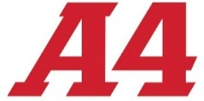
Located just a few miles from A4's previous headquarters, the Vernon facility provides additional capacity while allowing the company to maintain continuity for its employees and local customer base. "We wanted a location that allowed us to grow without disrupting our team or the relationships we've built in Southern California," Mertens added.
The Vernon expansion follows A4's recent growth in Kansas City, Missouri, and the addition of other brands, marking the company's third major expansion in the past two years.

New A4 Address
4505 Bandini Blvd.
Vernon, CA 90058

Press Contact: Adam Waugh, awaugh@A4.com
ABOUT A4 – A4 operates on a simple principal: Provide the highest quality athletic apparel at the lowest possible prices. We do this by cutting out the companies in the middle. A4 designs, cuts and sews more of its own apparel than our competition. We do this to maintain higher quality control and provide better performing garments. And, since we aren’t paying others to do this work, we pass that savings on to our customers. This formula has made A4 a leading supplier of team uniforms and sports apparel to thousands of team dealers, screen printers and others who support tens of thousands of schools, leagues, teams and companies. Learn more at www.A4.com.

